Detroit City FC Salesforce Project Notes

# 4/11/2025 - Presales Kickoff Call

## Precall Notes from Todd

* From Dan Amato who is a consultant/friend working with us on Salesforce project:
  + General project scope for salesforce implementation work with associate work lift is:
    - 1.) Hubspot to Salesforce integration (small-medium lift)
    - 2.) SeatGeek integration to Salesforce (medium-large lift with access to SeatGeek backend database/API dependency)
    - 3.) Call Harbor integration (sales call log software fox and team use)
    - 4.) Quickbooks (medium/large lift depending on access and third party connections)
* Noah will also be on the call he works with ticket sales and does a mix of sales and data integration for our marketing efforts.

## Pre Call Research

* **HubSpot** integration - [https://academy.hubspot.com/lessons/salesforce-integration-with-hubspot?_gl=1*1uocajm*_gcl_au*NDE0NDMxNTc1LjE3NDQzNzc0Nzc.*FPAU*NDE0NDMxNTc1LjE3NDQzNzc0Nzc.*_ga*NTE1NTUzMDUwLjE3NDQzNzc0Nzg.*_ga_LXTM6CQ0XK*MTc0NDM3NzQ3Ny4xLjAuMTc0NDM3NzQ3OC41OS4wLjA.*_fplc*azRXVFdhJTJCSzlLQXplcGJrSUdxQllteHQ2R2xPMGtZelY3c3ljR05JbVVHSFVhUjA0QXRBRnNEWG1aJTJCNjdsb1FoRmU3JTJCcnQ0QnBhbkhCeWp1Tm8lMkJPQUJWUzd0dERzRW1CaXZzUCUyQmVjQm5wc1lRbXJBMGFBYnpWRG13aFllZyUzRCUzRA](https://academy.hubspot.com/lessons/salesforce-integration-with-hubspot?_gl=1*1uocajm*_gcl_au*NDE0NDMxNTc1LjE3NDQzNzc0Nzc.*FPAU*NDE0NDMxNTc1LjE3NDQzNzc0Nzc.*_ga*NTE1NTUzMDUwLjE3NDQzNzc0Nzg.*_ga_LXTM6CQ0XK*MTc0NDM3NzQ3Ny4xLjAuMTc0NDM3NzQ3OC41OS4wLjA.*_fplc*azRXVFdhJTJCSzlLQXplcGJrSUdxQllteHQ2R2xPMGtZelY3c3ljR05JbVVHSFVhUjA0QXRBRnNEWG1aJTJCNjdsb1FoRmU3JTJCcnQ0QnBhbkhCeWp1Tm8lMkJPQUJWUzd0dERzRW1CaXZzUCUyQmVjQm5wc1lRbXJBMGFBYnpWRG13aFllZyUzRCUzRA)..
  + Managed package configurable integration settings
* **SeatGeek** Integration - <https://seatgeek.com/build>
  + Custom development using APIs.
  + Requires a SeatGeek account to access the docs.
* <https://callharbor.com/> - VOIP Phone System
  + Website says it easily connects to Salesforce but didn’t list any technical documentation. Google search didn’t reveal any either. We would want to engage a Call Harbor person to get us the technical details.
* **Quickbooks** - Middleware is recommended but based on forums it looks like APIs might be available.
  + <https://quickbooks.intuit.com/learn-support/en-us/account-management/how-to-connect-to-salesforce-is-there-a-way-to-integrate/00/1443820>
  + We will need technical contact to get us going.

## Call Notes

* Todd Kropp, Noah Hochstetler, Dan
* Todd’s priorities:
  + Ticket Sales
  + How to leverage other platforms
  + Square
  + Shopify
  + Food & Beverage Side - Cheq (Cantalope)
* Plan to be in the new stadium in 2027
* Noah thoughts:
  + Get sales CRM setup and streamlining sales processes
  + Expand outward to build full data platform
  + Do we have families with kids in youth programs
  + Building to scale up in the new stadium
  + He realizes integrations may need middleware
  + Season ticket renewal
  + 12-18 months to get the new CRM setup
* Dan thoughts:
  + Agrees with Todd & Noah
  + HubSpot data into SF is phase 1
  + pHase 2 - more integrations:
    - Call Harbor - Dan mentioned he spoke to someone who said Call Harbor has a free integration tool
    - SeatGeek
    - Corporate partnerships
    - Merchandise
    - Main goal is to get a complete customer profile to help drive sales.
* Dan mentioned other teams used Boost for integrations. We don’t know much about this.
* They use Mailchimp for marketing.
* They are just using HubSpot as a database right now. Probably doesn’t make sense to integrate this. This isn’t connected to SeatGeek.
* They like mail chimp.
* Sales Process Today:
  + Sales Reps work out of google sheets or some lists, also have Google Forms through mailings or on the Website.
  + When they get the leads they go into HubSpot or the google sheets to see if anyone has worked with this lead before. Then give it to sales rep. Look at SeatGeek to see history then figure out how to approach them.
  + Sales Reps create reminders and tasks.
  + They then decide to convert them.
  + Add notes on opportunity and sales numbers.
* **~~ACTION ITEM~~**: Send Todd, Dan and Noah SOW for phase 1 & 2

# 5/16/2025 - Dave/Todd Sync on Project & SOW

# 5/28/2025 - Prep for June 5th Official Project Kickoff Call

* Attendees for the call:
  + Todd Kropp - [todd.kropp@detcityfc.com](mailto:todd.kropp@detcityfc.com) - Co-Owner & COO
  + Noah Hochstetler - [noah@detcityfc.com](mailto:noah@detcityfc.com) - Account Executive
  + Dan Jamato - [danieljamato121@gmail.com](mailto:danieljamato121@gmail.com) - Consultant - Wrote the “Detroit City FC: Salesforce Migration Planning” slide deck
  + Steve Fox - [Steve.fox@detcityfc.com](mailto:Steve.fox@detcityfc.com) - VP of ticket sales
  + Archer Guanco - [archer.guanco@detcityfc.com](mailto:archer.guanco@detcityfc.com) - new hire who will be focused half-time on data projects.
  + Hitesh Nimje - [hitesh@redleafsoftware.com](mailto:hitesh@redleafsoftware.com) - Lead Solution Consultant at RedLeaf Software
  + Dave Avery - [davery@redleafsoftware.com](mailto:davery@redleafsoftware.com) - Chief Architect and Project Manager at RedLeaf Software
* Agenda:
  + Introductions
  + Unified objectives review
  + Phase 1, 2 & 3 outline
  + RedLeaf Roles & Responsibilities
  + Detroit City FC Roles & Responsibilities
  + How we will work together
    - The process
    - The methodology
  + Next Steps

# 6/5/2025 - Official Project Kickoff Call

Attendees: Dave A., Todd, Archer, Evan

* 3 FTE Sales Reps
* User in the system:
  1. Noah - admin
  2. Dave - admin
  3. Todd - Exec
  4. Steve - Exec
  5. 3 Reps - Sales Rep
  6. Archer - Admin
  7. New SF Admin - Admin
  8. Karim - Box Office - Builds SeatGeek impl. - Will need access, not sure on role/profile.
* Do we want Sales Reps to see each other’s data?
  1. Yes, we do want visibility across this.
  2. We want to restrict access to change contact owner. We want them to see all the details.
* Products/Verticals:
  + Seats
  + Suites
  + Groups
* B2B
* B2C
* Noah’s dream workflow: reps fill out data in SF while on the phone with customer/lead/contact.
  + Identify what they are looking for.
  + Identify any objectives.

## Hitesh Action Items in new Sandbox

* Setup role: DCFC Staff
* Profiles: (bare bones; no object access, FSL, etc.)
  + System Administrator
  + Executive
  + Sales Rep
* Permission Sets: (object access, FSL, everything we can in here)
  + Sales Process (edit access to all, but can’t change ownership)
  + Executive Reporting
* Build standard SF sales process workflow. Need Hitesh’s brilliance =]
* Use Product, Pricebooks and Pricebook Entries.

**~~ACTION ITEM~~**: Dave, create DCFC Security Matrix for Hitesth to maintain.

* 7/14/2025 - Added to Task tracker (T-5)

# 6/6/2025 - Daily Stand Up

Attendees: Dave, Archer, Evan, Hitesh, Noah

* URGENT: What’s the status of Dave’s access in production?
  + Just completed this on the call. Dave now has prod access.
* Contact Sheet: <https://docs.google.com/spreadsheets/d/1v8Mpsbh_YjIc43Kfb6StspLEc2LA99_PtmdlDTRZCqI/edit?usp=sharing>
  + **~~ACTION ITEM~~**: Dave, share with everyone and have them enter info.
* Dave setup meetings as discussed at kickoff.
* Hitesh working on standard sales cloud impl to workshop with the team to see what works and what doesn’t.
  + **~~ACTION ITEM~~**: Noah to send .png to Hitesh. He will also include style guide. Just as a reference, we don’t need to strictly adhere to this.
* Hitesh, asked if we can have a Q&A sheet to keep track of everything.
  + **~~ACTION ITEM~~**: Dave, to create and share this.
* Noah, is on slack. Dave just started convo with Hitesh, Noah & Dave.

# 6/10/2025 - Daily Stand Up

Attendees: Dave, Noah, Hitesh

* Hitesh, going over document he created, <https://docs.google.com/spreadsheets/d/1R-p9ACbSUfWP7t_mwlig2cEN0uWCn9ujV8cir8PgKKM/edit?gid=918303627#gid=918303627>, talked to:
  + Timeline
  + He created roles, profiles, permission sets
  + He lead us through questions for Noah.
    - Answered in the spreadsheet
  + Dave provided high level explanation of Campaigns, Leads, Accounts, Contact, and Opportunities. Then talked about the overall Sales Process.
  + **~~ACTION ITEM~~**: Hitesh, remove Campaign tab for now from Detroit City FC app.
  + We are going to start with just one Sales Process. This will be used for B2C and B2B initially.
  + We are building both the mobile and desktop functionality the same. This will help sales in the field. Even at the soccer games.
  + It would be nice for Sales reps to see their own Sales Revenue and commissions but not other reps info.
    - **~~ACTION ITEM~~**: Hitesh, use lightning page conditional visibility based on record owner to hide Sales Revenue details from Sales reps. Execs and Admin should always see this.
      * 7/14/2025 - Added to Task tracker (T-4)
  + **~~ACTION ITEM~~**: Noah to send Dave & Hitesh customer data. Just export is good for now for us to identify fields. We will start with export from SeatGeek to get us started.
  + **~~ACTION ITEM~~**: Noah, confirm DCFC fiscal calendar.
    - Noah confirmed Business Hours are 9 AM - 5 PM - Mon - Fri.

Our ongoing Project Notes can be seen here,<https://docs.google.com/document/d/1AbO_Yv5e-kvXJSLFrxppk7BU_KzwcB_TCNVr9_Nra6E/edit?usp=sharing>

# 6/11/2025 - Daily Stand Up

Attendees: Dave, Noah, Hitesh

* Noah sent documentation from SeatGeek. Exported from Unify.
  + These are people who have season tickets already. This really maps towards contact data, not leads.
* **~~ACTION ITEM~~**: Noah, send lead centric data from Group & Premium Seating via the Google Forms. Most of these folks have already been contacted by our Sales.
  + **~~ACTION ITEM~~**: Noah to send data from HubSpot. This will map to activities taken on these leads from the Google Forms data.
    - 6/23 - Received.
* Dave asked Noah, how could we see in current data who the owner is? There might be something in HubSpot we can use, but we will have to look at the data.
* The existing data isn’t all tied together so we will have to cross reference the info as best we can in Excel.
* If customer/email, is in HubSpot they would have been contacted, so that describes a status for a lead. It would be something further along than New.
* Noah shared screen for HubSpot view.
* There are several contacts in HubSpot with no owners. Noah mentioned they have a HubSpot integration to their email system, Google. So contact via email get automatically sent to HubSpot. No additional data but a contact is created.
* Here is a screenshot of HubSpot interface.

* Here is a contact details screenshot.

* The data Noah sends Dave/Hitesh is just for info purposes for us to build the Schema in Salesforce.
* Noah said he will also play a little more in Unify to get more details that might help us associate the data between systems.
* Here is a screenshot from HubSpot for the Primary Company, this would map to a SF account.
* There are a lot of companies and contacts in HubSpot that we will want to have a migration activity for. Accounts, Contacts, Leads.
* We’ve identified data that can map to Accounts, Contacts, Leads, and Activities, but haven’t found anything that would map to Opportunities.
  + They had an intern working on something for renewal opportunities, but I don’t think we can load this.
* Noah asked if we can pull over our product from SeatGeek.
  + Yes, these will map to Products and Pricebooks.
* Here is a screenshot of the list of deals in HubSpot.

* Here is a screenshot of the deal details.

* This would be a good mapping into the Opportunities record, but we don’t have too much info for these.

* Noah says there is more info in SeatGeek we may want (e.g. lifetime spend).

Our ongoing Project Notes can be seen here,<https://docs.google.com/document/d/1AbO_Yv5e-kvXJSLFrxppk7BU_KzwcB_TCNVr9_Nra6E/edit?usp=sharing>

# 6/16/2025 - Daily Stand Up

Attendees: Dave, Hitesh, Noah

* Reviewed action items from prior days.
* Hitesh led us through a demo of the recommended solution based on what we’ve gathered thus far.
* TODO: We need to figure out how Leads get assigned and/or chosen.
* As Hitesh demonstrated the Quote, Noah asked how flexible the configuration around Taxes are. Hitesh said it is configurable.
* **~~ACTION ITEM~~**: Hitesh enable emailing in Dev1 sandbox.
  + **~~ACTION ITEM~~:** Mask current customer emails
    - This is in our Task tracker (T-1)
* Noah gave example of “Friends of the Club” discount. We want some flexibility in adding discounts to our Opportunities.
* **~~ACTION ITEM~~**: Dave & Hitesh, look into discounting options with the SF SKUs purchased today. We don’t have QPQ.
* Noah talked about four different price types. Two days before the game it goes up.
* **~~ACTION ITEM~~**: Noah to send Hitesh and Dave current pricing in Excel. We will parse it and see how to best represent this in SF.
  + 6/17 - Noah sent “2025 DCFC Pricing Overview - SF.xlsx” - uploaded here, <https://docs.google.com/spreadsheets/d/1u-N0vRcYH1kdIEErFK-ZG9ujeThzYmyV/edit?usp=sharing&ouid=109911022161712648722&rtpof=true&sd=true>
* **~~ACTION ITEM~~**: Hitesh to build current Google Form into a Web to Lead form in SF.
* Noah talked about Google form data that ties into what we are doing in SF. Managers assigned leads and enriched the data. The Sales reps manually create contact in HubSpot from this. There will be overlap between this and previously sent HubSpot data.
  + **~~ACTION ITEM~~**: Noah to Hitesh & Dave this info.
    - 6/17 - Noah sent “2025 DCFC Group Leads - SF.xlsx” - uploaded here, <https://docs.google.com/spreadsheets/d/1qu0Z6m5jljL_8ARSFczpPnMyUifdPwDG/edit?usp=sharing&ouid=109911022161712648722&rtpof=true&sd=true>
      * This illustrates who the owner is in the Sales Rep column.
      * This is an example of what we can use for a Web to Lead form.

Our ongoing Project Notes can be seen here,<https://docs.google.com/document/d/1AbO_Yv5e-kvXJSLFrxppk7BU_KzwcB_TCNVr9_Nra6E/edit?usp=sharing>

# 6/18/2025 - Daily Stand Up

Attendees: Dave, Noah

* Hitesh is out sick today.
* Dave asked Noah, how do people get the Google form today?
  + It is linked on website & socials.
  + It gets included in emails.
  + **IDEA**: We will be replacing the Google form with the new Web to lead for inserting new leads directly into SF for the Sales Team to process.
* Dave is recommending a Sales Team Queue which can be used to assign and/or take ownership of new Leads.
  + **~~ACTION ITEM~~**: Hitesh, setup new Sales Team Queue. We will present a solution to Noah and modify from there.
* Dave is also focussed on some project management tasks to keep us organized.
* Noah expressed interest in getting more involved with Salesforce. We will get him hands on asap.
  + **~~ACTION ITEM~~**: Noah, get signed up for a Trailhead account.
    - We completed this on the call.
  + **~~ACTION ITEM~~**: Dave, activate Noah’s user record in Dev1 and show him how to get in there.

Our ongoing Project Notes can be seen here,<https://docs.google.com/document/d/1AbO_Yv5e-kvXJSLFrxppk7BU_KzwcB_TCNVr9_Nra6E/edit?usp=sharing>

# 6/19/2025 - Bi-Weekly Project Check In Call

Attendees: Dave, Noah, Todd

* It’s Juneteenth and DCFC is officially closed.
* Here is the presentation we reviewed on the call: <https://docs.google.com/presentation/d/19D7RQia98_UQez5xi5_EgJ8Ja4qd0kkF4VCY1qkJGcg/edit?usp=sharing>
* Todd asked Noah, what the volume is on the Google Form.
  + Noah said this has been used since 2022. We have 300 - 500 submissions since then. We hope to increase the volume on this.
  + Todd discussed a good use case to how this could be used while talking to folks at a St. Lois game.
* Dave demo’ed the Sales Process.
  + Todd asked how much can we automate?
    - Dave replied as much as we want to. Example: automate the follow up task to a quote being sent.
* Todd brought up the idea of showing this solution to a wider audience in Mid-July to make sure we are on the right track:
  + Initial Audience:
    - Project Team
    - Julie - CFO
    - Partnerships - sponsorship team
    - Others
* The new stadium is opening in Spring of 2027. There are 15k seats in the new stadium.

Our ongoing Project Notes can be seen here,<https://docs.google.com/document/d/1AbO_Yv5e-kvXJSLFrxppk7BU_KzwcB_TCNVr9_Nra6E/edit?usp=sharing>

# 6/20/2025 - Daily Stand Up

Attendees: Dave, Noah, Hitesh

* Hitesh completed stories assigned to him on dupe rules and web to lead form.
* Hitesh demo’ed web to lead form. We can require whatever fields we like. Let’s go with:
  + First Name
  + Last Name
  + Email
* **~~ACTION ITEM~~**: Hitesh, add the Recapcha to the form.
  + 6/23 - added but can’t demo today.
* **~~ACTION ITEM~~**: Hitesh, add “Questionnaire Details” to the Lead page layout with the questions on the Web to lead form.
  + 6/23 - added and will demo next meeting.
* Noah mentioned we keep the schedule of games updated in the.
* After submit it redirects to dcfc home screen. We can have it go wherever.
* In SF, we see the new lead with all the answers.
* Hitesh then walked us through the Lead duplicate rule.
* Hitesh made the sharing rules public read/write for Account, Contact & Lead.
* Hitesh also enabled emailing from the sandbox.
* Hitesh mentioned he is going to setup some email templates to demonstrate on our next session.
* **~~ACTION ITEM~~**: Hitesh, config the emails to send from the user’s emails. This is when the dialogue starts with the rep and customer.
  + 6/23 - done.
* **~~ACTION ITEM~~**: Hitesh, research SF to Google Email & Calendar to sync.
* **~~ACTION ITEM~~**: Dave, create QA1 sandbox.
* **~~ACTION ITEM~~**: Hitesh, send Dave latest manifest and any pre/post deployment activities to push current solution to QA1 when it’s ready.
  + 6/23 - reminded Hitesh of this and Dave and Hitesh will sync up soon on this.
* Next week is a full week.
* The following June 30th - July 9th, Dave it OOO.
* Noah is OOO 7/2 - 7/6
* Hitesh is OOO 7/9 - 7/11

Our ongoing Project Notes can be seen here,<https://docs.google.com/document/d/1AbO_Yv5e-kvXJSLFrxppk7BU_KzwcB_TCNVr9_Nra6E/edit?usp=sharing>

# 6/23/2025 - Daily Stand Up

Attendees: Dave, Noah, Hitesh

* Dave triggered creation of QA1 sandbox.
* Regarding Gmail & Calendaring Sync.
  + Dave research this and we have Salesforce Go and what we recommend to turn on is:
    - Einstein Productivity - this analyzes activities and provide great reports.
    - Google Calendar Sync - Hitesh to demo this feature in Dev1
    - Google Email Sync - Hitesh to demo this feature in Dev1 and see if we want this. Should be good, but just in case.
    - **~~ACTION ITEM~~**: Hitesh, enable all of three of these above in Dev1 and prepare demo for Noah.
      * Dave took ownership of this and not doing for now.
* **~~ACTION ITEM~~**: Hitesh, enable multi factor authentication in Dev1.
  + We will allow Salesforce Authenticator and Google Authenticator.
* Hitesh built a custom permission and granted this to himself and Noah for now.
  + **~~ACTION ITEM~~**: Dave to test.
* **~~ACTION ITEM~~**: Hitesh, create three test Sales Rep accounts. One test user for Hitesh, Dave and Noah. These will be connected to each of our MFAs.
  + **~~ACTION ITEM~~**: Dave, fully enable Noah’s account in Dev1.
* Tomorrow, Dave has a thing in the morning and might be late. He’ll move the meeting if so and send message on slack.
* Wednesday, Dave requested to back the meeting up.
  + **~~ACTION ITEM~~**: Dave, move meeting to 2:30 PM ET.

Our ongoing Project Notes can be seen here,<https://docs.google.com/document/d/1AbO_Yv5e-kvXJSLFrxppk7BU_KzwcB_TCNVr9_Nra6E/edit?usp=sharing>

# 6/25/2025 - Daily Stand Up

Attendees: Dave, Hitesh, Noah

* Dave triggered creation of QA1 sandbox.
  + 6/24 - this completed and Dave has logged in.
* Dave verified users without specific permission cannot change Lead ownership.
* Dave inquired with Hitesh to investigate why we are seeing the duplicate alert on all leads.
  + Hitesh looked into this and a lot of leads share the same phone and email.
  + Let’s work to get a single data load spreadsheet going.
* Data Migration Activities:
  + **LEADS**: We want to start organizing the lead data we will be uploading into production.
    - **~~ACTION ITEM~~**: Dave, send Noah a template to copy/paste data into.
      * 7/14/2025 - Added to task tracker (T-2)
    - **~~ACTION ITEM~~**: Noah, put together clean, non-duplicated data for final load.
      * 7/14/2025 - Added to task tracker (T-3)
  + **ACCOUNTS & CONTACTS**: This would maintain information for people and groups we have already sold to.
    - Noah mentioned he would be able to run reports on Unify (SeatGeek backend).
      * **~~ACTION ITEM~~**: Noah, to decide/discuss with the team, if they want to load legacy data for tickets previously sold.
      * Noah, mentioned the data in Unify isn’t 100% accurate for 2022. 2023, 2024, 2025 is pretty reliable.
* Hitesh worked on
  + MFA
  + Updates on the Web to Lead form.
* Hitesh demo’ed updates.
  + **~~ACTION ITEM~~**: Hitesh, remove note that lead doesn’t have dupes.
* We can create templates to reuse.
  + **~~ACTION ITEM~~**: Noah to reach out to the Sales Team for their common templates they send to leads.
* Here is the auto reply email from the Web to Lead form.
* **~~ACTION ITEM~~**: Dave, reset Noah’s password in Dev1. He didn’t activate it in time.
  + Completed this 6/25 @ 3:22 PM.
* NOTE: We don’t want to send emails to Sales Reps when a Lead gets assigned to them. We will show them a notification in SF instead.
* Noah commented that we want to start tracking our lead sources.
  + There is a standard field on the Lead -> Lead Source
* **~~ACTION ITEM~~**: Hitesh, write automation (trigger or flow) on the Lead and Contact objects to change the email address to be email += ‘.invalid’. This will prevent us from accidentally sending them an email from our development or qa sandboxes. We won’t migrate this to production.
  + 7/14/2025 - Update: added to task list (T-1) a while ago but not complete yet.

Our ongoing Project Notes can be seen here,<https://docs.google.com/document/d/1AbO_Yv5e-kvXJSLFrxppk7BU_KzwcB_TCNVr9_Nra6E/edit?usp=sharing>

# 6/26/2025 - Intro Call

Attendees: Dave, Todd, Andrew

* Dave gave intro on himself and the project.
* Andrew talked about his time at Columbus soccer club. They used Core which was built on SF and was their ticketing system.
* Andrew is currently with Austen FC. Giving demo of this system.
* Andrew mentioned when a customer opts out to renew their membership it triggers an opportunity, I doubt it’s an opportunity, probably a task to follow up and see if we can get them back.

Group Sales Dashboard

This is the app exchange package for Kore

* **~~ACTION ITEM~~**: Dave, look into KORE - <https://appexchange.salesforce.com/appxListingDetail?listingId=a0N4V00000DZUNjUAP>
  + 7/14/2025 - Added to Task Tracker (T-6)
* Andrew says most MLS companies are working with this or Microsoft Dynamics but it doesn’t work nicely with SF.
* Andrew said the money still goes through SeatGeek and Unify.
* Andrew thinks Kore is the integration mechanism between SF & SeatGeek.
* Andrew said Austen uses Person Account and Business Accounts.
* They use Qualtrix for their surveys
* Talked about Cadences he couldn’t show this but spoke to it. It sounds like a marketing campaign. He defines a list of emails and adds users to it. The emails get sent over time. He can define the first two touchpoints as emails, then a phone call.
* Andrew said they have DialPad integrated with SF. It has Einstein and summarizes calls.
* Having the ability to mass upload leads is useful too.
* Todd asked Andrew, what do the Sales Reps do when they come in in the morning. Andrew said they work off a TODO list with due dates. The Sales Reps might have their own tasks too (e.g. lead said to call them back in two weeks).
* DialPad has the ability to pre-record and leave voicemails if a call from Sales Rep to lead goes to voicemail. This saves a lot of time repeating the messages.
* Andrew talked about using an App for the new stadium.
  + Have a QR code for access
  + Prove memberships
  + Dave was thinking about a community for this.

## Follow up email from Andrew after the call

Hi Dave and Todd,

Following up on our call this morning—after connecting with our BI team (who will continue to be a great resource if any questions come up), I wanted to share a few updates.

On the ticketing side, we've recently moved much of our workflow into native Salesforce and now primarily use Kore for data integrations between Salesforce and Unify/SeatGeek.

However, on the partnerships side, Kore still plays a larger role in helping us manage pipeline, sold and available assets, and fulfillment tracking. That said, I was told Kore has taken a bit of a step back recently, and there's a chance we may explore other integration partners moving forward. BI shared a few alternatives for us to keep in mind:

1. [Purveyor Sports](https://www.purveyorsports.com/)
2. [Agilitek Solutions](https://agiliteksolutions.com/)
3. [601 Analytics](https://601analytics.com/)

Let me know if you have any questions on that front.

Best,

Andrew

# 6/26/2025 - Daily Stand Up

Attendees: Dave, Noah, Hitesh

* Hitesh provided updates:
  + Analysis on Gmail and SF integrations
  + Worked on adding the .invalid to our existing Leads & Contacts
  + He experienced Setup access issues.
  + He provided Lead, Account & Contact excel templates.
* Dave discussed whether to use Person Accounts or not. Talked about the pros & cons.
  + Noah talked about current data in Unify. They do business with Contacts.
  + Dave mentioned he’s leaning towards Person Accounts so all sales are against an Account, not a mix between Accounts & Contacts.
    - We can always relate Account to Account or Contact to Contact.
  + **DECISION**: We are going with Person Accounts. This helps with reporting and adoption. This is how the current team treats people.
    - **~~ACTION ITEM~~**: Hitesh, enable person accounts and incorporate the __pc fields in our Account data load template.
      * Enabled on 7/8/2025 in Dev1.
* Noah, mentioned they just purchased a list of 11,000 Leads in the Detroit area. Lots of data points on this.
  + **~~ACTION ITEM~~**: Noah, send Dave & Hitesh the raw spreadsheet.
    - 6/26 - Noah sent this with the following comment: Here is the excel with all of the leads we just purchased. They are sorted by industry and group type (Big Business & Group Categories). We would still like to keep those two parts of the sheet separate, as they will be on separate campaigns. Let me know if you have any additional questions or if I can provide any additional background.
    - Link to this spreadsheet - <https://docs.google.com/spreadsheets/d/1pPpjE0w2sEIz3f0VrGaQLCWAYgDZ-z1g/edit?usp=sharing&ouid=109911022161712648722&rtpof=true&sd=true>
* Hitesh asked Noah if he has an idea on how we want to assign Leads to the various Sales Reps.
  + **~~ACTION ITEM~~**: Noah to confirm with Steve Fox on process. We know we want ability for Noah & Steve to manually assign leads, but don’t want to introduce a bottleneck on hot leads.
    - 7/14/2025 - Noah confirmed on a subsequent DSU that Steve was good with our even spead of leads to reps.
  + Hitesh demonstrated how lead assignment rules work, it’s based on certain fields on the lead driving assignments to sales reps. This is great for geographical territories but we are not there yet. Every Sales Rep can sell all products to all customers.
    - **~~ACTION ITEM~~**: Hitesh, to start we will round robin our Lead. Grab total active Leads and divide by count of Sales Reps (3) and evenly assign. Then Noah/Steve can reassign if a good reason to do so.
      * Create Notification and start sales journey.
      * On our User Story tracker (US-33).
* To start we won’t create a Sales Journey that automates action items, email, etc.. Instead, we will leave it up to the Sales Rep to define the Next Step at every interaction.
* Over time we will build automation to make the Sales Reps way more efficient.
* Noah spoke to Steve about how much legacy data from Unify. We are grabbing everything but total sales value from Unify. This will include data beginning 2023.
  + Noah may break out exports 2022 & 2023 with no sales value.
  + Use 2024 & 2025 with total sales value.

Our ongoing Project Notes can be seen here,<https://docs.google.com/document/d/1AbO_Yv5e-kvXJSLFrxppk7BU_KzwcB_TCNVr9_Nra6E/edit?usp=sharing>

# 6/27/2025 - Daily Stand Up

Attendees: Dave, Noah

* Hitesh had something come up and couldn’t make the DSU.
* Noah worked with SeatGeek team on export process. Looks like we will get all the info in one full sheet.
* Dave explained how we are still working on import templates based on enabling the person accounts.
* Noah talked to Steve and he is good with evenly distributing leads between reps.
* Reminders:
  + Dave is OOO 6/30 - 7/9.
  + Noah is OOO 7/2 - 7/6.
* Noah mentioned DCFC has a small gap between home games and will get back to Trailhead training.

Our ongoing Project Notes can be seen here,<https://docs.google.com/document/d/1AbO_Yv5e-kvXJSLFrxppk7BU_KzwcB_TCNVr9_Nra6E/edit?usp=sharing>

# 7/11/2025 - Daily Stand Up

Attendees: Dave, Noah, Steve, Hitesh

* Noah mentioned the Sales Reps have already started working the new leads.
* Hitesh is working on Change Set for initial QA1 push and noticed fields created by Noah. Should we include these in our manifest?
  + We noticed some custom fields on the Opportunity object created by Noah on 5/23/2025.
  + **~~ACTION ITEM~~**: Dave, look at production to see if these are relevant or even there. For now, don’t include them in manifest.
    - 7/14/2025 - Looks like we are not the first to notice this, <https://trailhead.salesforce.com/trailblazer-community/feed/0D54S00000A8u6QSAR>. I started creating a case with Salesforce using Agentforce but my conversation with it made me think we should keep these.
      * Here is my conversation: <https://docs.google.com/document/d/1SXf3H1Dkj9Bt9Xdrekwb3yIV2bD-lmsdxKHC5pTa9Hw/edit?usp=sharing>
      * 7/14/2025 - Noah agreed to keep these too.
* In the NET NEW - Detroit City-Group Prospects emails (1).xlxs spreadsheet Noah sent 6/27, review the following fields and define the mappings to the Lead object fields:
  + SIC CODE - **~~ACTION ITEM~~**: Hitesh: Create Identical Field to map into.
  + SIC CODE DESCRIPTION - **~~ACTION ITEM~~**: Hitesh: Create Identical Field to map into.
  + GROUP CATEGORY - **~~ACTION ITEM~~**: Hitesh: Create Identical Field to map into.
  + SALES VOLUME CODE
    - Steve says there is a legend for this as well. This is useful if we know the mapping.
    - **~~ACTION ITEM~~**: Steve, send Dave the legend for this.
      * 7/11/2025 - Steven sent email (cc’d Noah). Noah saw reply and forwarded to Dave.
        + **~~ACTION ITEM~~**: Dave, update info text accordingly.
    - **~~ACTION ITEM~~**: Hitesh: Create Identical Field to map into. Dave will send details when available.
  + DO NOT MAIL - We will ignore for now; do not load this column.
  + SEGMENT - **~~ACTION ITEM~~**: Hitesh: Create Identical Field to map into.
  + ID NUMBER - **~~ACTION ITEM~~**: Hitesh: Create **Full House Marketing External ID** field to map into.
  + DISTANCE
    - This is the distance from Key Worth, the stadium they play at.
    - **~~ACTION ITEM~~**: Hitesh: Create **Distance from Keyworth Stadium** Field to map into.
  + LOCATION TYPE - **~~ACTION ITEM~~**: Hitesh: Create Identical Field to map into.
* Steve Fox mentioned they bought these leads from Full House Marketing.
* Noah is waiting on the final template. Dave/Hitest to send soon after the above updates are in Dev1.
* Noah gave an update that he’s working with Justin at SeatGeek to get our data out of there. This will get loaded into Accounts, Contact & Opportunities. He also mentioned he can send screenshots of what fields are available to export.
  + **~~ACTION ITEM~~**: Noah, pull sample SeatGeek data with all fields and send it to Dave & Hitesh.
    - 7/14/2025 - Noah sent the “DCFC_Client_Info_Export.csv” spreadsheet shortly after our call. This has been uploaded to G-Drive, converted to a Google Sheet and accessible here: <https://docs.google.com/spreadsheets/d/1oFrS5mvNFbDYATqIA1blW2eX3z0TP3yxi5pw0P8WTic/edit?usp=sharing>
      * 104,357 rows
      * This looks like Contact data only; no Account information.
        + We can load these with no account or create a holder account to indicate these came from our Unify Data Load.
        + Do we want to require accounts going forward? We know we will be selling to individuals too and use the Person Account concept.

7/14/2025 - Noah said most of these are individuals, but could think of some that were related to a business (e.g. IBE).

There isn’t a way in Unify to identify these but Noah could work with Reps to sort through this.

Discussed that it might be helpful to identify single game buyers vs season ticket buyers. Maybe premium buyers and group.

**~~ACTION ITEM~~**: Noah, see if he can extract data from Unify with these breakdowns. Then we can load with attributes defined for this.

Our ongoing Project Notes can be seen here,<https://docs.google.com/document/d/1AbO_Yv5e-kvXJSLFrxppk7BU_KzwcB_TCNVr9_Nra6E/edit?usp=sharing>

# 7/14/2025 - Daily Stand Up

Attendees: Dave, Noah, Hitesh, Steve

* Review Action Items from 7/11/2025 DSU above. Many updates have been made.
* Dave went through all action items recorded here and ensured they were on our User Story or Task Tracker, <https://docs.google.com/spreadsheets/d/1BbgvQuchVJzDUnKQ1LFLKQ29PqHHqpJ6Ht9_y-bAEhs/edit?usp=sharing>.
  + I crossed out the **~~ACTION ITEM~~** reference in this document to indicate it’s either complete or managed on our tracker. No need to keep going back past the 7/11/2025 DSU section.
* Added US-34 to our user story tracker. Assigned to Dave to design the product/pricing solution.
* Discussion related to data to load:
  + **Hubspot** exported data - We would like to, but it’s difficult to know activity has been done on these leads. We can at least determine what Sales Rep owns what Lead from this data.
    - Mark these as Source = HubSpot.
      * **~~ACTION ITEM~~**: Hitesh, create new field called “Data Load Source”.
    - It makes sense to first load the Unify data, then compare this to the HubSpot data. From here, we will know more activity. If the lead came from Unify, no need to load again. We can load the remaining leads.
  + **Unify** Lead - Load the 104k records into Person Accounts (Account + Contact)
  + **Purchased** Leads - Load into Lead object.
* Hitesh, worked action items.

Our ongoing Project Notes can be seen here,<https://docs.google.com/document/d/1AbO_Yv5e-kvXJSLFrxppk7BU_KzwcB_TCNVr9_Nra6E/edit?usp=sharing>

# 7/15/2025 - Daily Stand Up

Attendees: Dave, Hitesh, Noah

* 7/14 Action Items - crossed out.
* Hitesh is focused on round robin lead assignment user story.
  + Question: Do we want our users to view converted leads? YES.
    - **~~ACTION ITEM~~**: Hitesh, build permission set to manage this.
* Dave completed Lead and Person Account data load templates (T-2 in tracker) and sent email to Noah.
* Noah hasn’t looked too much at the templates yet. He is working in Unify on extracting data into various sets.
  + We discussed process and created a Data Loads folder, <https://drive.google.com/drive/folders/1fnd7oDkcMobfkVk8U2mWbzJC6FGUdAJ3?usp=drive_link>, for Noah to work directly in. This will make it easy to collaborate on his updates.
    - **~~ACTION ITEM~~**: Dave, copy comments into the data load files. Add Type.
  + Noah brought up that he didn’t notice a “Lifetime Spend” column in the spreadsheet.
    - **~~ACTION ITEM~~**: Hitesh, add a new field “Lifetime Spend” on the Account object. Currency (16, 2)
  + Noah mentioned the Unify CRM ID is missing from the template.
    - **~~ACTION ITEM~~**: Hitesh, create new field Text(100) called “Unify External CRM ID” on the Account object.
* Noah mentioned the Do Not Email field, we don’t have anything in Unify for this. He isn’t going to worry about it.
* Lead - Flexi page & standard layout: removed required checkbox on the Company field.
* Sys Admin, Sales Rep and Executive, changed account default record type to Person Account.
* Enabled Person Accounts in QA1.
  + NOTE: We have a manually created Person Account Record Type in Dev1. DO NOT migrate this to QA1. It confuses the config, just use the automatically created one called “Person Account”.
* Began work on Product/Pricing Solution Design document, <https://docs.google.com/document/d/1oBrmM5yn-VNe-tCkZSruVO7r78JMk5KlH4bbdG28g0s/edit?usp=sharing>.
  + Do we have a concept of Product Codes at DCFC? This is usually a SKU or shortened abbreviation. It’s optional and probably not necessary given we only have a few products to worry about.
    - DCFC Doesn’t use Product Codes.
      * **~~ACTION ITEM~~:** Dave, remove Product Code from the layouts.
* Noah discussed more complicated pricing in Unify. Eventually, we want these integrated so more accurate revenue in SF is available.
* For today, we will go forward with existing pricing that Noah sent Dave and is in the above SDD. This will demonstrate the flexibility of the system.
* IDEA: Can have an override discount with the products we have from SF today?
  + **~~ACTION ITEM~~**: Dave, see if we can come up with an easy custom solution to add a discount in.
* Dave modified the Lead Source field on the lead object.
  + **~~ACTION ITEM~~**: Hitesh, add this to the Change Set.
* Hitesh mentioned we can leverage a managed package “Enhanced audit tracking” which is free.
  + We won’t add until we need to.

Our ongoing Project Notes can be seen here,<https://docs.google.com/document/d/1AbO_Yv5e-kvXJSLFrxppk7BU_KzwcB_TCNVr9_Nra6E/edit?usp=sharing>

# 7/17/2025 - DCFC Project Check In

Attendees: Dave, Archer, Steve, Andrew, Noah

Slide Deck Reviewed: <https://docs.google.com/presentation/d/1tYY6QdZ6kAztZGRiBcsmA8LC9qeIw4GwULs6iIqHoUY/edit?usp=sharing>

* Andrew asked about options for ticketing partnering info. I didn’t dig into those yet.
  + Dave response, this is a phase 2 item. We will focus on that after this effort.
* Andrew said add our most senior, Rahsan Noris, on the review for page layouts.

Our ongoing Project Notes can be seen here,<https://docs.google.com/document/d/1AbO_Yv5e-kvXJSLFrxppk7BU_KzwcB_TCNVr9_Nra6E/edit?usp=sharing>

# 7/17/2025 - Daily Stand Up

Attendees: Dave, Noah, Hitesh

* Noah is working on the Data Load files.
  + Currently, we only have one column for PersonMailingStreet.
    - **~~ACTION ITEM~~**: Dave, look into the best approach for this.
* Hitesh hit limit with flow and switch to use the trigger.
* Dave:
  + Put together bi-weekly check in slide deck.
  + Continued work on product/pricing solution
  + Modified some config and keeping track of changes for the manifest.
  + Reviewing the overall process and making minor enhancements.

Our ongoing Project Notes can be seen here,<https://docs.google.com/document/d/1AbO_Yv5e-kvXJSLFrxppk7BU_KzwcB_TCNVr9_Nra6E/edit?usp=sharing>

# 7/18/2025 - Daily Stand Up

Attendees: Dave, Noah

* Dave - demo’ed extra feature to discount Quote Line Items. Noah dug this feature to help one-off situations.
* Dave - Feedback to Noah on Street 1 & 2 lines.
  + Noah added this and is working on queries in Unify.
    - He said the result of the formula is looking a little funny. It’s pushing street2 right up to street1.
      * **~~ACTION ITEM~~**: Noah, send to Dave and we can both look into this.
  + He is seeing a lot of the data is empty, but that’s OK.
* Noah mentioned when the data went from Passage to Unify, the first and last name fields were reversed.
  + There isn’t a good way to identify which records were affected. It would require manual clean up to correct this.
  + He is noticing some trends to help identify this.
* Noah mentioned we are not keeping good track of Active. There are a lot of records with very limited data. He will decipher what to bring to SF.
* Noah and I discussed Phase 2 (SeatGeek integration) might change a little with Andrew’s input and any new priorities that are surfacing. No problem at all. We will do what’s best for DCFC.

Our ongoing Project Notes can be seen here,<https://docs.google.com/document/d/1AbO_Yv5e-kvXJSLFrxppk7BU_KzwcB_TCNVr9_Nra6E/edit?usp=sharing>

# 7/21/2025 - Daily Stand Up

Attendees: Dave, Noah, Hitesh, Andrew

* Dave - Completed all Product Pricing setup and SDD - <https://docs.google.com/document/d/1oBrmM5yn-VNe-tCkZSruVO7r78JMk5KlH4bbdG28g0s/edit?usp=sharing>
* Noah, still cranking away on data loads. He has more availability to work on this the middle of this week.
* Hitesh, Completed the Lead assignment user story.
  + **~~ACTION ITEM~~**: Hitesh, to lead a peer review with Dave before demoing to Noah & Andres.
* Review User Stories & Tasks.
* Andrew brought up, when working with leads, Sales Rep checks out the lead. His thoughts align with our current solution.
* Andrew also brought up the use of Round Robin to assign leads. There is a 30 day window of lead assignments. If no action has been taken the lead goes back into the “Round Robin” pool.
* Andrew mentioned, if a Sales Reps makes a sale, they should maintain the relationship for a year. If no sale, it makes sense to switch up the reps.

Our ongoing Project Notes can be seen here,<https://docs.google.com/document/d/1AbO_Yv5e-kvXJSLFrxppk7BU_KzwcB_TCNVr9_Nra6E/edit?usp=sharing>

# 7/22/2025 - Daily Stand Up

Attendees: Dave, Hitesh, Noah

* Dave:
  + Code Review and feedback
  + Finished product code task
  + Optimizing layouts - Added tasks for the team.
* Hitesh:
  + Finished Round Robin, is currently incorporating feedback
* Noah:
  + Sent Dave an email.
    - **~~ACTION ITEM~~**: Dave, to review this.
  + Cleaned up data to remove nonsense rows. Our new total is around 73k from Unify.
  + Created separate report to get lifetime spend in Unify. Added tab2 and used vlookup for the data load file.
    - Some results in Unify are N/A, $0 and valid values.
      * **~~ACTION ITEM~~**: Noah to blank out N/A values. This would most likely cause import error.
  + Still having street1 & street2 formatting issues.
  + He is still working on flipping first and last names for some bad data.
  + Noah is OOO next week Wed-Fri (7/30 - 8/1).
* We reviewed Lead page layout on New scenario.

Our ongoing Project Notes can be seen here,<https://docs.google.com/document/d/1AbO_Yv5e-kvXJSLFrxppk7BU_KzwcB_TCNVr9_Nra6E/edit?usp=sharing>

# 7/23/2025 - Daily Stand Up

Attendees: Dave, Noah, Hitesh

* Dave:
  + Fixed new vs existing layout issue we saw yesterday.
* Hitesh:
  + Test code coverage
  + Consolidated triggers lead and contact
* Noah:
  + Similar to yesterday.
  + He did reach out to marketing on Lead Source values.
* As a team we continued page optimization.
* **~~ACTION ITEM~~**: Hitesh, when demeaning the change owner logic we put in. I, Dave, couldn’t change owner after you assigned me the permission.
* **~~ACTION ITEM~~**: Dave test conditional visibility to Lead Flexi Page -> Questionnaire section to only show if Lead Source equals “Website”.
* We talked about using the Highlight panel or not. Noah, mentioned from his selling days this will be useful. It is a best practice from SF.
  + When in “Smile and Dial” mode, having quick glance fields is helpful.
  + We will use the highlight panel on the Lead.
* Talked about 2/3rds, 1/3rd view layout. We will use this and have the first 2/3rds section be Details. ⅓ section will be activities like we have on the Lead record.

Our ongoing Project Notes can be seen here,<https://docs.google.com/document/d/1AbO_Yv5e-kvXJSLFrxppk7BU_KzwcB_TCNVr9_Nra6E/edit?usp=sharing>

# 7/24/2025 - Daily Stand Up

Attendees: Dave, Hitesh, Noah, Steve

* Dave:
  + Looked into Noah’s email and the Street1 & Street2 issue.
    - <https://1drv.ms/x/c/df3876c000681dfb/EfxG4PKf0dZOum47BsGYm1ABs8B_XIQpbHFGEWZuUt6rRw?e=dmRI1l>
    - For the formatting of combined street we just needed to enable cell wrapping and extend the size to see it properly formatted.
    - I applied the “wrap” to the spreadsheet, then downloaded to CSV. It looks good.
* Hitesh:
  + Question about mapping lead fields to Accounts, Contacts, Opportunities.
    - **~~ACTION ITEM~~**: Hitesh, create the Questionnaire (see “2025 DCFC Group Leads - SF.xlxs) & Full House Marketing (see NET NEW - Detroit City-Group Prospects emails (1).xlxs) fields on the Opportunity object and map these from the Lead on conversion.
  + Finishing feedback
  + Finalizing manifest.
  + Finished test apex classes and updated triggers.
  + Found a bug when logged in as Sales Rep 1: The activity bar on the right is missing the buttons to create task, event, log a call.
    - **~~ACTION ITEM~~**: Hitesh, investigate this issue.
* Noah:
  + Talked to Steve and started thinking about when to show this to the sales reps.
    - Waiting on clean QA1 build.
    - Asking them top lead data points for our highlights panel.
* Steve:
  + Checking on progress and agreed on timing to bring in the sales reps.
* Dave asked about training the sales reps. Should we do a big zoom call? Should Dave train, etc.?

Our ongoing Project Notes can be seen here,<https://docs.google.com/document/d/1AbO_Yv5e-kvXJSLFrxppk7BU_KzwcB_TCNVr9_Nra6E/edit?usp=sharing>

# 7/25/2025 - Daily Stand Up

Attendees: Dave, Noah, Steve, Hitesh

* Dave:
  + Mobile demo prep
* Asked what would be the primary tool: Phone or Browser? Noah said 90% of the time they will be on the browser.
* Discussed Lead Statuses:
  + **Not Interested**
    - Guidance:
      * Use default but clean up with new status name.
    - Key Fields:
      * Not Interested Reason
    - Validation: Call was connected, an email was returned, or the Not Interested Reason field populated.
      * **~~ACTION ITEM~~**: Dave, solution this in the system.
  + **Untouched** (Default)
    - Guidance:
      * Use default but clean up with new status name. We don’t need the “assign to sales rep” line.
      * Gather all the key fields to the left.
      * Next Step: Reach out via phone or email
    - Key Fields:
      * Email
      * Phone
      * Mobile
      * Company
      * Website
  + **Contacted**
    - Guidance:
      * This indicates we’ve reached out to them and pending a response to gauge interest.
      * Continue to monitor this lead for a period of time to determine interest.
      * Set a reminder for yourself to reach back out to this lead in a couple of days if you haven’t heard back.
      * Try different times of day on different times of day.
    - NOTE: Consider automation to keep on top of this lead for two weeks.
    - Key Fields:
      * Rating
  + **Qualified**
    - Automatically goes to this when converted.
  + **~~ACTION ITEM~~**: Dave, put this status and path details together in Google Doc and share with Noah and Steve to complete.

Our ongoing Project Notes can be seen here,<https://docs.google.com/document/d/1AbO_Yv5e-kvXJSLFrxppk7BU_KzwcB_TCNVr9_Nra6E/edit?usp=sharing>

# 7/28/2025 - Daily Stand Up

Attendees: Dave, Noah, Hitesh, Steve

* Reminder: Noah is OOO Wed - Fri this week.
* Dave:
  + Created Lead Sales Process Doc - <https://docs.google.com/document/d/1Hsm7eW_arqxRV8mn-Y24wP6dzgI9lQWJIy9KCPYzrq8/edit?usp=sharing>
    - Shared this with the team and asked Noah & Steve to update.
  + Created Opportunity Sales Process Doc - <https://docs.google.com/document/d/1y6NXRG-nwNVy-kkryiSRC8-kqUrUhMCPBmtyYbtLg48/edit?usp=sharing>
    - Need to review this with the team and assign it to Noah and Steve to finalize details.
  + Started DCFC Security Matrix.
* Noah:
  + Data load prep - tagged Archer in to help with the first & last name flipping issue.
  + Had a few other projects pop up at the club.
  + Archer will also get the leads from Full House formatted correctly.
    - Noah mentioned a lot of these leads would have been sold to so they wouldn’t be leads any more. How to handle?
      * Once these leads have been identified we will determine the next steps.
  + Season ticket inquiry form - want to load this info into SF as well. Let’s look at this data and figure how to get it in SF.
  + Started working out guidance for the opportunity sales process.
* Hitesh:
  + Created the Not Interested lead status.
    - Added corresponding validation.
  + Added questionnaire and Full House Marketing fields on the Opportunity.
  + Investigating Sales Rep permission issue.
* Noah committed to getting the Lead Sales Process document finalized before he leaves on Vaca.
* After the Lead Sales Process, Noah & Steve will focus on the Opportunity Sales Process.
* We agreed we will use the 2/3rds, 1/3rd layout for Accounts, Contacts and Opportunities.
* Noah asked if Closed Won or Closed Lost has to be the final status.
  + No, it can be whatever we define. Noah mentioned they want the Sales Reps to follow up after the game.
* Noah mentioned the Sales Reps responded to the top five fields.
  + A rep asked if we can have a “Last Contacted Date” field. We don’t have this field yet. We can add it but will require automation to maintain this field.
  + Discussed proximity field, this is useful in certain scenarios.
  + Noah thinks we are good with what we have so far.

Our ongoing Project Notes can be seen here,<https://docs.google.com/document/d/1AbO_Yv5e-kvXJSLFrxppk7BU_KzwcB_TCNVr9_Nra6E/edit?usp=sharing>

# 7/29/2025 - Daily Stand Up

Attendees: Dave, Hitesh, Noah, Steve

* Noah:
  + Working on Lead & Opp Sales process docs.
* Hitesh:
  + Sales Reps Activities permission bug has been resolved.
* Dave:
  + Account flexi page updates
* We walked through the Account Flexi page.
  + **~~ACTION ITEM~~**: Dave, figure out how to edit the highlights panel for business vs person accounts. We are using the same flexi page.
  + **~~ACTION ITEM~~**: Dave, now that we’ve decided on Business and Person sections, do a first pass at appropriate fields to review with the team.
* Noah is OOO the rest of the week.
  + We are cancelling Wed & Thurs DSU (this call).
  + The project check in is still on for Thursday.
  + Friday DSU is still on, Dave & Hitesh can use this to finalize some tasks.

Our ongoing Project Notes can be seen here,<https://docs.google.com/document/d/1AbO_Yv5e-kvXJSLFrxppk7BU_KzwcB_TCNVr9_Nra6E/edit?usp=sharing>

# 7/31/2025 - DCFC Project Check In

Attendees: Dave, Andrew, Steve

Slide Deck Reviewed: <https://docs.google.com/presentation/d/1UD2_aJzgK8_RoY7pGtKLBKJ-vl_1kpYaQBoZ81EdxcE/edit?usp=sharing>

* Andrew asked about dashboards & reports. This is on the list of things to do.
* Andrew also asked about using partners for the Sales Process. This hasn’t been discussed too much so we can focus on the initial sales team. Eventually, we do want them on SF.
  + There is a lot of room for growth here.
* Andrew discussed how they used partnership in SF for activations. There is a lot we can do in the system to help manage this process.
* Discussed the potential to use Sales Cadences.
* Andrew brought up integration between SF & SeatGeek (Unify). He talked to owner of Purveyor Sports, who has the ability to do the integration. They also have data warehouse. They could help from a reporting standpoint too. We have licenses with Unify until 2027, so won’t be switching before then. There was talk about moving off of them.
  + Billing Models to work for Purveyor Sports:
    - Additional charge per month
    - Per transaction fee added to ticket sales
  + The Next Steps are for us to connect with Purveyor Sports.
    - **~~ACTION ITEM~~**: Dave to connect with Todd on the priority for this.
* Dave talked about timeline and pushing to go live in August, so we stay on budget.

Our ongoing Project Notes can be seen here,<https://docs.google.com/document/d/1AbO_Yv5e-kvXJSLFrxppk7BU_KzwcB_TCNVr9_Nra6E/edit?usp=sharing>

# 8/1/2025 - Daily Stand Up

Attendees: Dave, Hitesh

* Hitesh, can we remove the RoundRobinLeadTrigger with the new LeadTrigger?
  + YES
* Live testing today on the call while logged in as Sales Rep 1.
* **~~ACTION ITEMS~~**: Hitesh:
  + Grant access to reports and dashboard for Sales Reps.
  + Logged a call, then clicked on Call and on the Details screen I couldn’t see the description. I can if I click on the arrow to extend it from the Lead page layout.
  + Same issue with a Task.
  + When we try to set the Lead Status to Qualified, which is triggered to Convert, we are not getting the Conversion screen. We are as Sys Admins.
  + NOTE: When testing Business Accounts make sure to use records that have Record Type of Business Account Record Type (e.g. CompanyName30).

Our ongoing Project Notes can be seen here,<https://docs.google.com/document/d/1AbO_Yv5e-kvXJSLFrxppk7BU_KzwcB_TCNVr9_Nra6E/edit?usp=sharing>

# 8/4/2025 - Daily Stand Up

Attendees: Dave, Noah, Steve, Hitesh

* Dave:
  + First draft of all lightning page layouts complete.
* Hitesh:
  + Working Noah’s shared Lead Process. Notices some field discrepancies, see <https://docs.google.com/document/d/1nZJQpGuQCt1_8E7vbHQEu-RXpbLsX3Q3yOIeAO_9xmw/edit?tab=t.0>. We made updates directly here. Note action item captured for Hitesh.
* Noah:
  + Archer sorted out the B2B and Group leads. Noah to review, but looking good.
  + First and Last names issue is down to 10k; 80% corrected. Should be done before the initial estimate of 8/15.
* Steve:
  + No updates.

Our ongoing Project Notes can be seen here,<https://docs.google.com/document/d/1AbO_Yv5e-kvXJSLFrxppk7BU_KzwcB_TCNVr9_Nra6E/edit?usp=sharing>

# 8/5/2025 - Daily Stand Up

Attendees: Dave, Noah, Steve

* Noah mentioned a new renewal process for season ticket holders has been pushed forward. They are going to live with this next Tuesday. We originally wanted to roll this out in SF.
* Hitesh a little out of pocket to take care of family issues.
* We reviewed the Contact Lighting Page Layout - DONE.
* We reviewed the Quote Lighting Page Layout - DONE.
* Target for QA deployment is FRIDAY.

Our ongoing Project Notes can be seen here,<https://docs.google.com/document/d/1AbO_Yv5e-kvXJSLFrxppk7BU_KzwcB_TCNVr9_Nra6E/edit?usp=sharing>

# 8/7/2025 - Daily Stand Up

Attendees: Dave, Steve, Noah, Hitesh

* Dave:
  + Updated Opportunity Path - see notes in Noah’s Doc: <https://docs.google.com/document/d/1hRcTINzGPEwFNW4bNSSiMyY2nHdaKfQi3fHtgiGQRKo/edit?tab=t.0> for fields and guidance character limits
  + While discussing the Proposal Stage Noah brought up the need for a new field, **Stadium Section** - Picklist (Bench Box, VIP, Gold, Rouge, City Supporters, Roosevelt Corner, Family, Railyard Club). Default None. Sorted alphabetically
    - **~~ACTION ITEM~~**: Dave, Add this field and add it to Proposal key fields in the Path. Remove Amount which we have in the highlights panel.
    - We discussed the Opportunity Forecast Category, Stage and the Post Closed Follow Up concepts. An alternative option is to remove this stage and have a Post Closed Follow Up Completed checkbox. Noah and Steve like this idea but want to have automation for a follow up task.
      * Closed Won - Auto tasks:
        + Before the game (10 days before the game)

“Send client a text, email or give them a phone call ensuring they have everything they need for match day.”

* + - * + After the game (1 business day after the game)

“Follow up with the client after the match to thank them for their business and to ask for referrals.

Provide your contact information again and remind them to keep in touch for future sales opportunities!”

* + - * **~~ACTION ITEM~~**: Dave, create new field **Post Closed Follow Up Completed** checkbox
      * **~~ACTION ITEM~~**: Dave, build automation for tasks described above.
      * **~~ACTION ITEM~~**: Dave, remove Post Closed Follow Up from path and Opportunity Stage.
  + Discussed a few missing fields on the Opportunity:
    - Payment Schedule/Type but this really isn’t too important.
  + When do we consider an Opportunity Closed Won?
    - Closed Won stage change
    - Payment received
  + Noah brought up idea on “Payment in Process” step in the Sales Process before Closed Won.
    - **~~ACTION ITEM~~**: Dave, email Andrew to see if he can join the call tomorrow.
      * 8/7 - sent email right after the call.
* Hitesh:
  + Updated Lead Path - see notes in Noah’s Doc: <https://docs.google.com/document/d/1nZJQpGuQCt1_8E7vbHQEu-RXpbLsX3Q3yOIeAO_9xmw/edit?tab=t.0#heading=h.v89fk8ggyazv> for guidance character limits.

Our ongoing Project Notes can be seen here,<https://docs.google.com/document/d/1AbO_Yv5e-kvXJSLFrxppk7BU_KzwcB_TCNVr9_Nra6E/edit?usp=sharing>

# 8/8/2025 - Daily Stand Up

Attendees: Dave, Andrew, Hitesh, Noah, Steve

Follow up discussion points from 8/7:

* When do we consider an Opportunity Closed Won?
  + Closed Won stage change
  + Payment received
* Noah brought up the idea of the “Payment in Process” step in the Sales Process before Closed Won.

Notes from Today’s Convo:

* Andrew’s response when we viewed Opportunity Closed Won, was when we have the money in our account.
* Noah and Steve agreed with this idea.
* Noah talked about the Commission Report. Andrew said the Commission Report should still be pulled from Unify.
* We want to add a new Stage on the Opportunity called **Payment in Progress**.
  + Key Fields:
    - Payment Method - Picklist: Paid up Front, Payment Plan, Group Code
      * **~~ACTION ITEM~~**: Dave, add this field to the Opportunity and Path.
    - Closed Date
    - Amount
    - Description
  + Guidance:
    - You’re responsible for completion of payment on this sale. Use the Description field to note any specific details regarding collecting the payment.
      * **~~ACTION ITEM~~**: Dave, add the new field and add it to the path to show the team.
      * **~~ACTION ITEM~~**: Noah, think about any changes to this verbiage.
* We want to update the automation we discussed yesterday for Post Closed Follow Up.
  + Now, when the Stage changes to Payment in Progress:
    - --> Before the game (10 days before the game)
    - “Send client a text, email or give them a phone call ensuring they have everything they need for match day.”
    - --> After the game (1 business day after the game)
    - “Follow up with the client after the match to thank them for their business and to ask for referrals.
    - Provide your contact information again and remind them to keep in touch for future sales opportunities!”
  + **DECISION**: We are holding off on the automation for these follow up tasks until we are clearer on requirements.
* We talked about revenue reporting to be done from Unify. Potentially, we can just use SF after the integration is in place.
* We added the Post Closed Follow Up Complete field based on yesterday’s discussion. We still want this even with the Payment in Progress stage.

Our ongoing Project Notes can be seen here,<https://docs.google.com/document/d/1AbO_Yv5e-kvXJSLFrxppk7BU_KzwcB_TCNVr9_Nra6E/edit?usp=sharing>

# 8/11/2025 - Daily Stand Up

Attendees: Dave, Noah, Hitesh

* NOTE: I have to cancel 8/13 DSU.
* Noah mentioned Archer gave him an update:
  + Big Businesses are done with data clean up.
  + First & Last Name issue almost done.
  + We are well on track with clean data by Friday of this week.
* Hitesh, brought up Guidance on one status on the Lead object. We ran out of characters.
* Updated Lead Path - see notes in Noah’s Doc: <https://docs.google.com/document/d/1nZJQpGuQCt1_8E7vbHQEu-RXpbLsX3Q3yOIeAO_9xmw/edit?tab=t.0#heading=h.v89fk8ggyazv> for guidance character limits.
  + Hitesh put all the guidance in without the questions in bullet point #3. Noah, confirmed this looks good.
* **~~ACTION ITEM~~**~~:~~ Dave, add Lead and Opportunity path to manifest.
* We confirmed the Opportunity Page Layout.
* **~~ACTION ITEM~~**: Dave/Hitesh begin QA1 deployment.
* **~~ACTION ITEM~~**: Hitesh, create validation rule to prevent Sales Reps from changing the Opportunity Stage after it has gone to Closed Won. Admins and Executives can change this.

Our ongoing Project Notes can be seen here,<https://docs.google.com/document/d/1AbO_Yv5e-kvXJSLFrxppk7BU_KzwcB_TCNVr9_Nra6E/edit?usp=sharing>

# 8/14/2025 - Project Check In

Attendees: Dave A, Archer, Noah, Andrew, Steve

* Slide Deck Reviewed: <https://docs.google.com/presentation/d/1rVak1NnwQK3ddlUJeBZ8sOF62qf0Cz4XK5oZsCyLXa4/edit?usp=sharing>
* Noah and Archer let me know the data files are cleaned up. Noah is sending them over now.
* Went through slide deck.
* No new questions from the team.
* General census is project is progressing nicely.
* Noah discussed the new Season Ticket renewal process is underway. They’ve learned some new things we will want to incorporate into SF using the new process. He also mentioned they have new season ticket leads. These are coming from a Google Form. There are fields which indicate which reps have been working with those leads. We will want to get these into SF. This season ticket google form has some new questions that we would want to map to new lead fields.
  + We will want to replace these google forms with Web to lead forms soon. This will automatically input the data into SF.
* **~~ACTION ITEM~~**: Dave create the following accounts in QA1.
  + Steve
  + Archer
  + Andrew
  + Noah already has an account.

# 8/15/2025 - Daily Stand Up

Attendees: Dave,

* Noah won’t be here today.
* Dave:
  + Completed Security Matrix with some rework to our design.
  + Updated metadata in dev1 and qa1.
  + Created accounts for Archer, Andrew and Steve in qa1. Sent them follow up email.
    - What authenticator do we want to recommend?
    - **~~ACTION ITEM~~**: Dave, send instructions on how to connect an authenticator to the orgs once we confirm which one we recommend.

# 8/18/2025 - Daily Stand Up

Attendees: Dave, Noah, Hitesh, Steve

* Dave:
  + Authenticator?
    - Noah mentioned they don’t have anything universally established.
    - DECISION: Let’s use Salesforce Authenticator.
      * **~~ACTION ITEM~~:** Dave, put together and send instructions on SF Authenticator.
  + We will use Steve to walk through good tomorrow. They may be late to DSU tomorrow as they will be returning from an event.
  + I have conflict on Wednesday; cancelling call.
  + Lead Data Load (big business) - rows with no last name were omitted. This is a required field.
    - <https://docs.google.com/spreadsheets/d/1TwzEKBfpUw5OFWUejnTWkCBk0m59A09z_jdyADvqAT4/edit?usp=sharing>
  + Lead Data Load (Group outings) - interested products mapping issue.
    - <https://docs.google.com/spreadsheets/d/1_wnLl7oAvLf3A1tgwKicj50ECm8b5k9a_PpoxKg6zuI/edit?usp=sharing>
      * I set individual matches to “Single Match Tickets”
      * For all other values besides blanks I set it to “Groups”
      * I updated What_is_the_best_time_of_day_to_contact__c and Interested_in_which_Group_Outing__c to use ; instead of , between values.
      * The What_is_the_best_time_of_day_to_contact__c is a picklist, not a multi-select picklist. If column specified more than one value, I cleared the cell.
        + **~~ACTION ITEM~~**: Hitesh, convert this field to multiselect.

**~~ACTION ITEM~~**: Dave, reload original data.

* + - * For the Interested_in_which_Group_Outing__c column, I replaced Premium Group with General Group as we don’t have a Premium Group option.
      * For the Interested_in_which_Matches__c field, we had this as a multi-select picklist which wasn’t right. I changed this to a 131,072 char textarea field.
      * These guys had invalid emails:
        + **~~ACTION ITEM~~**: Noah, review these individuals to see if we have their emails. Send info to Dave.

|  |  |
| --- | --- |
| Matt | Hartwell |
| Erin | Moody |
| Mark | Hooks |
| Ryan | Nunley |
| Natalie | Phelps |
| Jonathan | Nurre |

* Person Account Data Load - <https://docs.google.com/spreadsheets/d/1oS0d2YE7uo_iQ2r1WyNwIBmZRnGP9lRr0A9tnQc6gC4/edit?usp=sharing>
  + Removed rows with invalid data for LastName (1, 2, 3, and other odd numbers or characters)
  + Broke imports into batches of 10k records. We had 72k to load.
  + Ran into issue with bad characters. Found and replaced appropriately.
    - Discussed that I, Dave, spent and hour cleaning up 10k records and still not done. I was able to load 20K without issue. I found weird characters in the FirstName, LastName and the Address fields.
    - **~~ACTION ITEM~~**: Noah to discuss with Archer to see if they can figure out a solution. Example row with bad data is CRM ID 23017. (e.g. 23017 Raymond √¢¬Ç¨¬èEl-Khoury)
* Discussed overall project and budget and the need to get the solution to production.
* When we get into QA with reps, Dave to lead session initially. We are planning to have our first training session, Wednesday - 8/27, 1:30 - 2:30. Another session Thursday, 8/28, same times.
  + **~~ACTION ITEM~~**: Dave, setup this meeting with Noah & Steve, Noah to forward.
* Hitesh brought up New Task Subject. . . do we want to provide any other options for them.
  + We will think about this and change config when we are ready.

Our ongoing Project Notes can be seen here,<https://docs.google.com/document/d/1AbO_Yv5e-kvXJSLFrxppk7BU_KzwcB_TCNVr9_Nra6E/edit?usp=sharing>

# 8/19/2025 - Daily Stand Up

Attendees: Dave, Noah, Hitesh,

* Dave:
  + Salesforce Authenticator - Put together this doc and shared it with Noah & Steve, <https://docs.google.com/document/d/1UmLoGcvADrV5APsrLHTBchAOgnJD8WuqZ_NGb3FxQJ4/edit?usp=sharing>.
  + **~~ACTION ITEM~~**: Dave, follow up with Steve to see if he could get in with these instructions.
    - 8/19 - Email Steve, Andrew & Archer (cc’d Hitesh & Noah).
* Reps who accepted training invites:
  + Rahsaan Norris <[rahsaan.norris@detcityfc.com](mailto:rahsaan.norris@detcityfc.com)>
  + Bryce Wolff <[bryce.wolff@detcityfc.com](mailto:bryce.wolff@detcityfc.com)>
  + Makenna Mascaro <[makenna.mascaro@detcityfc.com](mailto:makenna.mascaro@detcityfc.com)>
* We reviewed open items and there isn’t much. We are going to cancel these for this week then regroup right before training.
  + **~~ACTION ITEM~~**: Dave, cancel the DSU meetings for the rest of this week.
* Hitesh asked if we should remove conditional visibility on the Questionnaire section of the Lead so Sales Reps can always see this. Yes, we should.
  + **~~ACTION ITEM~~**: Hitesh, remove this conditional visibility in Dev1 & QA1.

Our ongoing Project Notes can be seen here,<https://docs.google.com/document/d/1AbO_Yv5e-kvXJSLFrxppk7BU_KzwcB_TCNVr9_Nra6E/edit?usp=sharing>

# 8/25/2025 - Daily Stand Up

Attendees: Dave, Steve,

* Today is a golf outing day, so a light crowd.
* Discussed the plan for the week with training and rolling out to production soon.
  + Dave to setup Sales Reps in QA without notifying them. We will turn them on officially after initial demo.
* Discussed phase 2 items: SeatGeek Integration and/or other providers.
* **~~ACTION ITEM~~**: Dave, reach out to Todd to see if he can attend Thursday’s Project Check In.

Our ongoing Project Notes can be seen here,<https://docs.google.com/document/d/1AbO_Yv5e-kvXJSLFrxppk7BU_KzwcB_TCNVr9_Nra6E/edit?usp=sharing>

# 8/26/2025 - Daily Stand Up

Attendees: Dave, Hitesh, Noah, Steve

* Who will be our production users? We only have 10 licenses.

1. Noah - Admin
2. Dave - Admin
3. Hitesh - Admin
4. Rashaan - Sales Rep
5. Bryce Wolff - Sales Rep
6. Mackena - Sales Rep
7. Steve - Executive
8. Andrew - Executive
9. Archer - Executive?
10. Todd - Executive?

* Discussed training and prod deployment plan. We hope to get started in prod by Friday. With the goal of reps using it Monday or Tuesday next week.
* Idea: invite the 3 reps to the DSU all next week after going live. This gives them an opportunity to provide feedback. They should all attend first DSU. We will have a few more just in case.
  + **~~ACTION ITEM~~**: Dave, put a slide deck together with how the rest of the project will play out.

Our ongoing Project Notes can be seen here,<https://docs.google.com/document/d/1AbO_Yv5e-kvXJSLFrxppk7BU_KzwcB_TCNVr9_Nra6E/edit?usp=sharing>

# 8/27/2025 - User Training - Day #1

Attendees: Dave, Hitesh, Bryce, Noah, Makenna, Steve,

* Training Slide Deck - <https://docs.google.com/presentation/d/1mrqugDFybxNEmYCfgu5dnaIw9sqO5z0wcOxWo9xnk24/edit?usp=sharing>
* Document: DCFC Logging into Salesforce for the First Time - <https://docs.google.com/document/d/1UmLoGcvADrV5APsrLHTBchAOgnJD8WuqZ_NGb3FxQJ4/edit?usp=sharing>
* Recorded Session:
  + Duration: 00:55:10
  + Share link: <https://us02web.zoom.us/rec/share/fiVyVYhUFL96HlGUSHeUVJvUQDMqwfA03jBe5qBxmHZQvRttl89KvfKbnPYM6pbJ.Yz_h4jToXklzm2tX>
  + Passcode: @OBh$K8M
* Rashaan - had an appointment and couldn’t attend.
* Going through Quote tab on the opportunity and noticed we didn’t have the New button.
  + **~~ACTION ITEM~~**: Hitesh, Get the New Quote button to appear on the Opportunity related list.
    - Hitesh addressed this during the call.
  + **~~ACTION ITEM~~**: Hitesh, Finish email config so we can email from SF.
    - False alarm, one time screen to choose how to email.
* Walked through getting Bryce logged into QA1.
  + He confirmed he is in.
* Makenna had some issues with Apple app store. She will work on this later.
* Asked for first impressions:
  + Bryce/Makenna say it looks good and likes a single source of info.

Our ongoing Project Notes can be seen here,<https://docs.google.com/document/d/1AbO_Yv5e-kvXJSLFrxppk7BU_KzwcB_TCNVr9_Nra6E/edit?usp=sharing>

# 8/28/2025 - Project Check In

Attendees: Dave A, Archer, Noah, Todd, Steve, Andrew

* Slide Deck Reviewed: <https://docs.google.com/presentation/d/1wZ1WbmMAmK9AwmCw1YPdD0-xWJqx6mpbupbTKG1AUOU/edit?usp=sharing>
* Discussing Phase 2 Options.
  + Todd said yes, we are good to begin that work and have the necessary conversations.
  + Andrew discussed options Purveyor Sports offers.
    - Predetermined Fee
    - Rev Share Model
    - **ACTION ITEM:** Andrew to send an intro email to set up a call.
  + Todd asked if there are any competitors (to Purveyor Sports) we should look at. We like to have options and comparisons.
  + We are tied to SeatGeek while at Keyworth Stadium. Can entertain others for the new stadium.
  + Andrew mentioned Purveyor Sports offers a Data Warehouse feature that comes with the solution. This could be valuable.
  + Andrew mentioned a lot of other teams (Louisville, Oakland) use Purveyor Sports. Noah knows folks from these clubs.

# 8/28/2025 - User Training - Day #2

Attendees: Dave, Noah, Steve, Hitesh, Bryce, Makenna, Andrew, Rahsaan

* Training Slide Deck - <https://docs.google.com/presentation/d/1mrqugDFybxNEmYCfgu5dnaIw9sqO5z0wcOxWo9xnk24/edit?usp=sharing>
* Document: DCFC Logging into Salesforce for the First Time - <https://docs.google.com/document/d/1UmLoGcvADrV5APsrLHTBchAOgnJD8WuqZ_NGb3FxQJ4/edit?usp=sharing>
* Recorded Session:
* **~~ACTION ITEM~~**: Histesh, Sales Reps shouldn’t see converted leads.
* While Bryce was adding a product as a Sales Rep to the Opportunity he received a system error. **~~ACTION ITEM~~**: Histesh, investigate and resolve.
* Makenna still hasn’t been able to download Salesforce Authenticator even after working with Apple. She can’t download anything on her phone.
  + **ACTION ITEM**: Makenna fix Apple account.
  + NOTE: We can turn off the MFA for single users if we need to, but don’t advise this security concession.
* Rahsaan has verified his email, but hasn’t downloaded SF Authenticator yet. **ACTION ITEM**: Rahsaan, He plans to look at it this weekend.
* NOTE: We are beginning the production deployment tomorrow, Friday, 8/29/2025. You will be working in production mid next week.

Our ongoing Project Notes can be seen here,<https://docs.google.com/document/d/1AbO_Yv5e-kvXJSLFrxppk7BU_KzwcB_TCNVr9_Nra6E/edit?usp=sharing>

# 09/02/2025 - Initial Call with Purveyor Sports

Attendees: Dave A., Hart Zwingelberg <hart@purveyorsports.com>; nate@purveyorsports.com <nate@purveyorsports.com>; andrew.flynn@detcityfc.com <[andrew.flynn@detcityfc.com](mailto:andrew.flynn@detcityfc.com)>

* Nate is from the Wineka Chicago area.
* Hart was in Chicago, but now lives in Charlestown, SC.
* Hart mentioned they have already had conversations with DCFC for fractional services.
* Nate mentioned he and Hart were both consultants. Nate was the CIO at the Big Ten sports conference. Hart works for Nate. Originally, tech guys who got into the sports industry. They started Purveyor Sports about a year ago.
* Nate says they will get the data into Salesforce.
* They have a partnership with SeatGeek.
* I asked what they provide technically.
* Hart said for DCFC we would get a cloud database (AWS), raw data storage, data warehouse, many models for ticketing, merchandising.
* Higher tier clients have a transformation layer.
  + Churn models
  + Rev Forecasting
* Sounds like they offer a lot more than what we need.
* They have a reverse ETL layer. Can bring a lot of data from SeatGeek back into SF.
* Walked through scenarios where a contact in SF bought a ticket in SeatGeek, then updated after the contact attended it.
* They have a BI layer we can access. There is AI on top of this.
* They are consultants like me but have precanned software to speed things up.
* I asked about pricing and Nate said they are super right sized for USL.
  + SeatGeek puts in back office fees into processing.
  + Essentially they cost $5k per month. Discounts for longer term agreements.
  + They could be free with fees passed on to consumers over time.
* They’ve done this for a few clients already and bring industry best practices to the table.
* They’ve already done SeatGeek integrations and SF integrations.
* They have a marketing product too. This could help Andrew a lot with future revenue growth.
* **ACTION ITEM**: Nate to make an intro to:
  + Louisville City. This is exactly what we want.
  + Portland Timbers (Purveyor sports is one layer; they are on the project scope)
* I’ve asked for a demo. We will set up a demo. Thursday some time 3-5 PM ET.

# 9/3/2025

* Finished the production launch and sent the following email to the team.

Hi Team,

We’re happy to announce that we have successfully completed the production launch!

As part of this release:

* We successfully migrated our solution from QA1 to the production environment.
* We loaded 72k+ Person Accounts from Unify.
* We loaded ~5k Leads for Big Business and Group Outings.
* Hitesh and I also performed a round of initial smoke testing.
* We encountered a few new issues which we were able to resolve.
* There is one issue that is still outstanding. It prevents you from adding a Product to an opportunity. After a few hours of troubleshooting on our end, we decided to engage Salesforce Support and created Case #: 471392380. I’ll let you know when this is resolved.

In a few minutes you will receive an email from Salesforce to setup your production account. Here is a link to the document we used to setup our accounts in QA1, <https://docs.google.com/document/d/1UmLoGcvADrV5APsrLHTBchAOgnJD8WuqZ_NGb3FxQJ4/edit?usp=sharing>.

If you’re using the Salesforce Mobile app, make sure you update your connection to production. We switched it to Sandbox for testing in QA1.

You will also receive meeting invites from me for the next days for us to connect and discuss any issues or question you may have.

Feel free to reach out via email if you have any questions before our calls.

Thanks,

Dave

* Then updated everyones’ email and reset password.

# 9/4/2025 - Production Support Call - Day 1 of 5

Attendees: Dave, Bryce, Rahsaan, Noah, Steve

* Bryce & Rahsaan confirmed they are able to get into production. Rahsaan is also on the mobile app.
* They haven’t had much time to work there yet. They plan today and the next few days. May have more feedback tomorrow.
* I mentioned the data loads with a small number of issues.
  + **~~ACTION ITEM~~**: Dave, to send results to Noah & Archer.
    - 9/5 - Sent email with links to Noah & Archer.
* Noah & Steve brought up a campaign idea. To incentivize customers to be season ticket holders in the new arena. We might data load this or the leads/accounts may exist already in SF.

# 9/4/2025 - Purveyor Sport Call

Attendees: Nolan Kruse (dev on Purveyor sports team), Nate Schnader, Hart Zwingelberg, Andrew Flynn

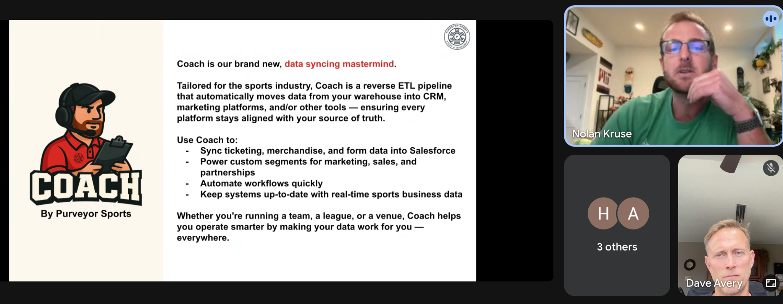

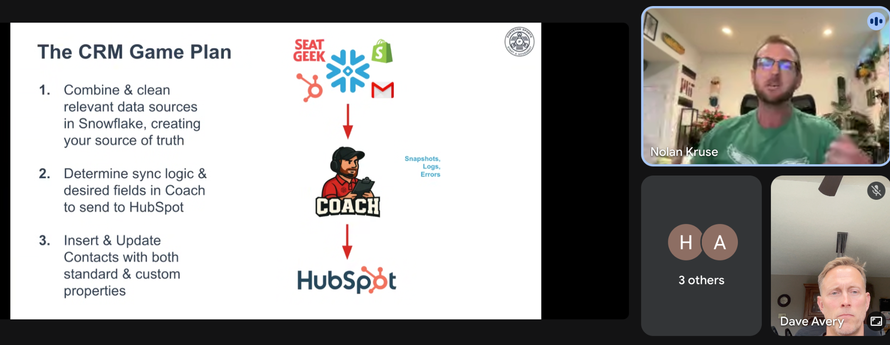

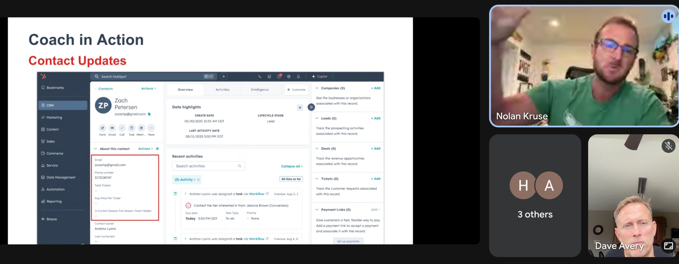

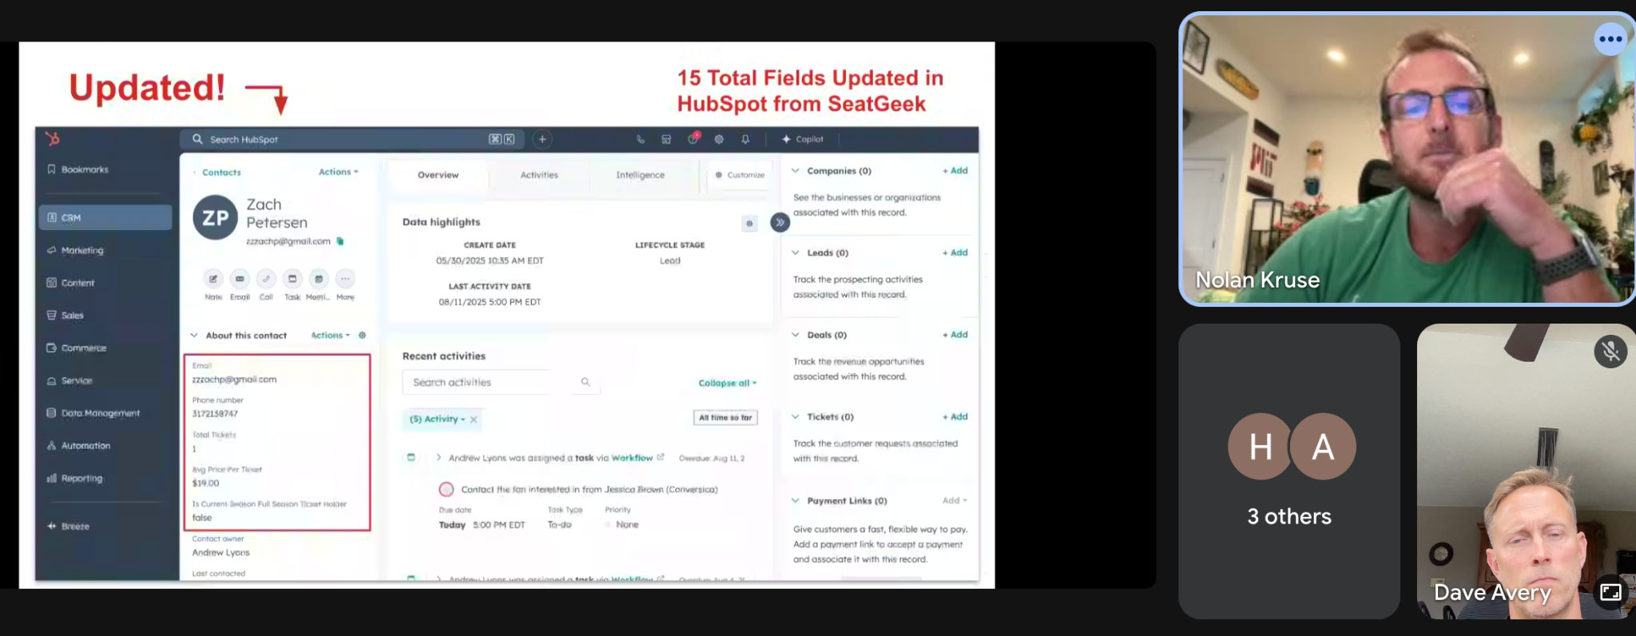

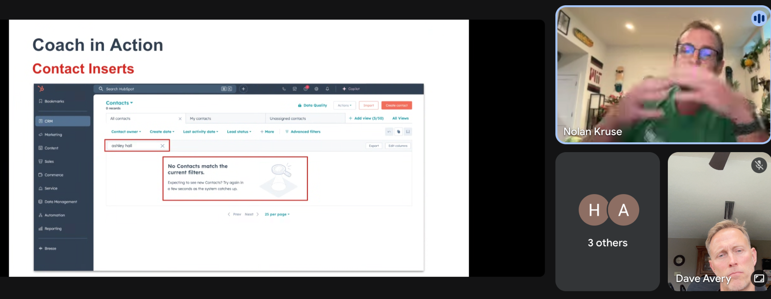

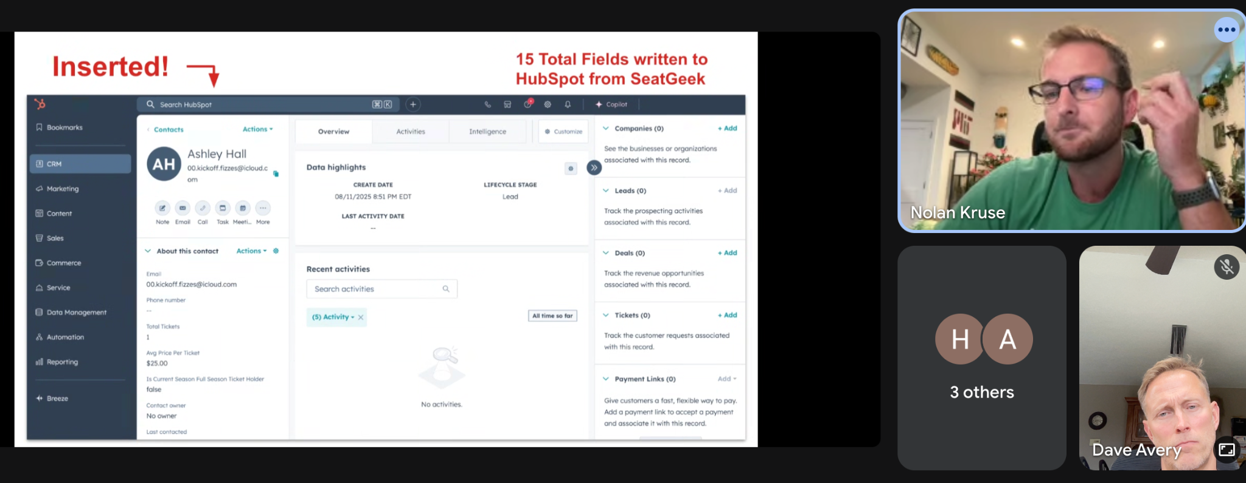

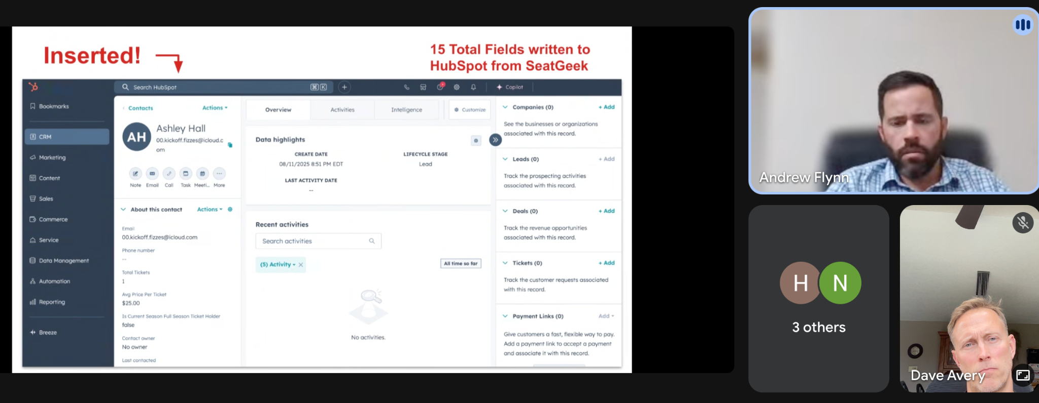

* Hart mentioned SeatGeek doesn’t allow us to write an Account/Contact in their system. It sounds like we would want this if the process starts in SF.

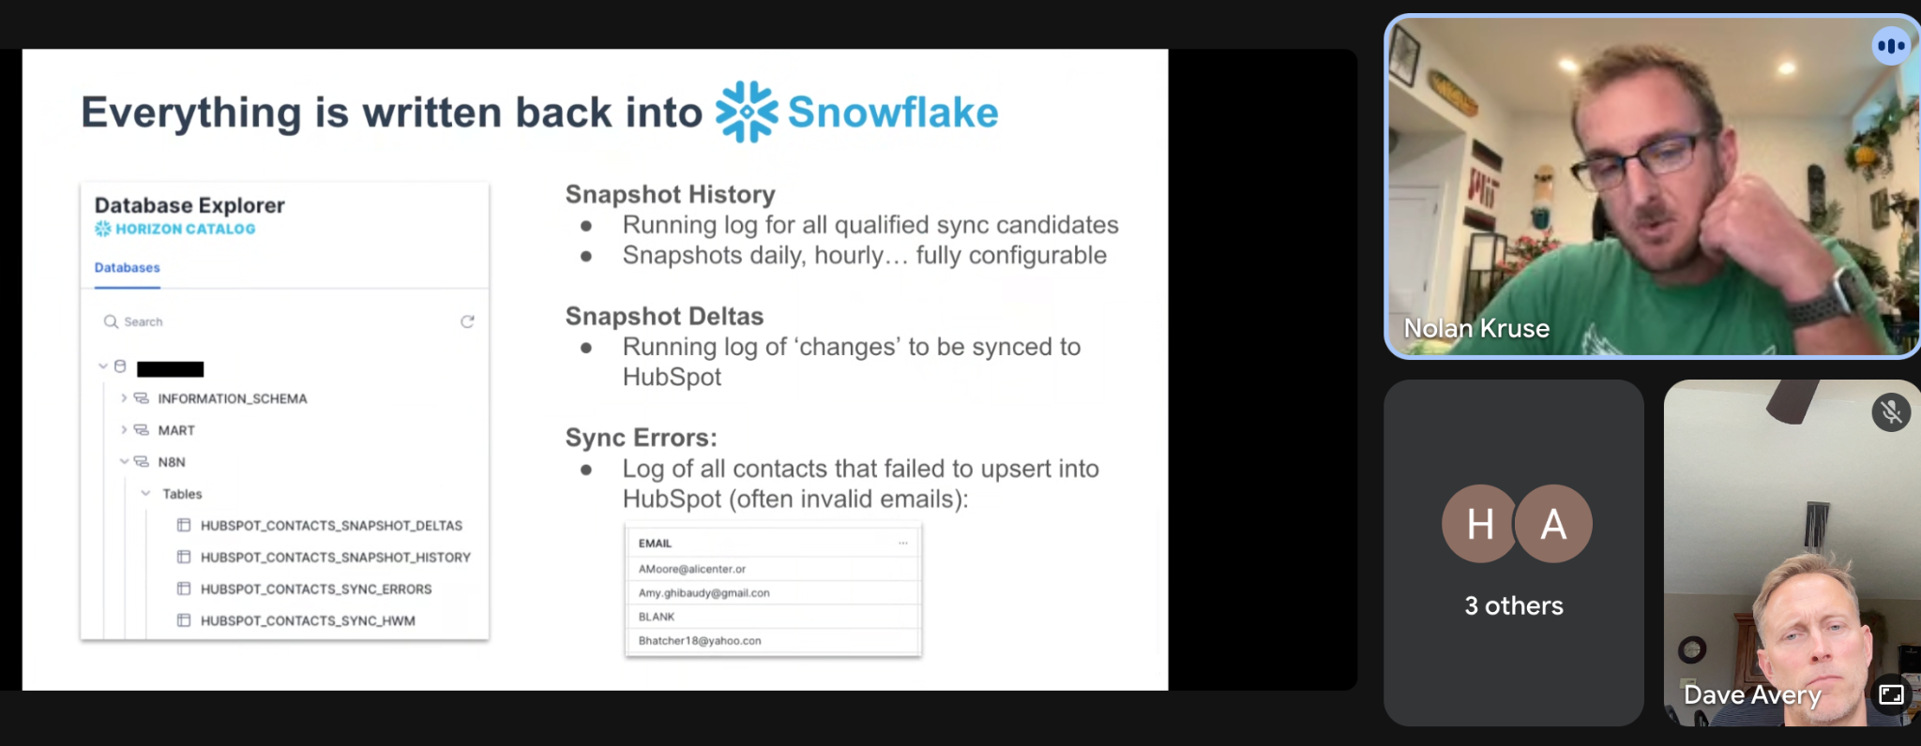

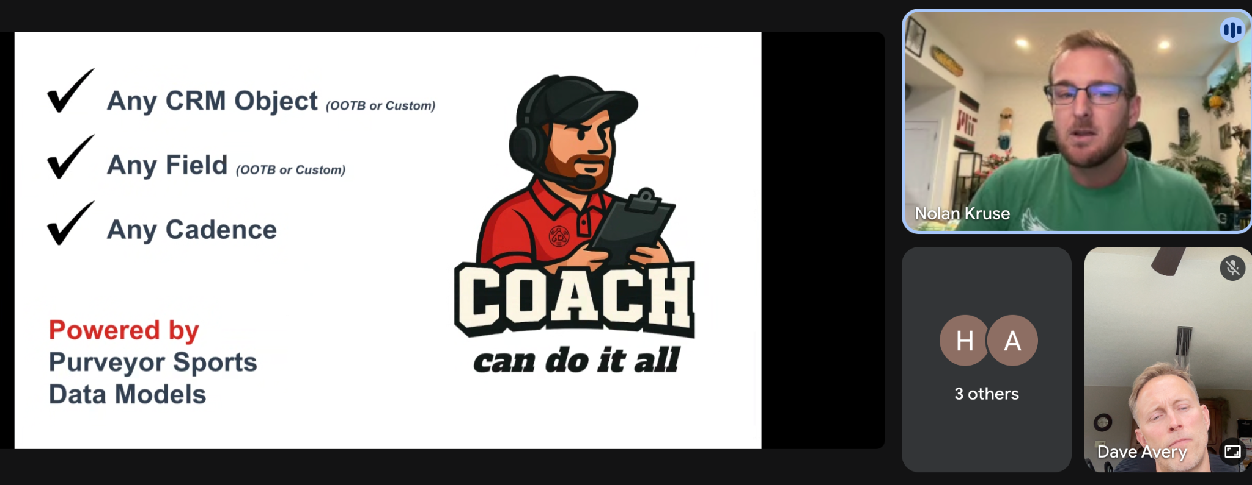

* I asked if Purveyor sports could facilitate a ticket sale into SeatGeek.
  + No, not really
* Purveyor sport is more of a data backup solution with insights.
* Hart gave demo of Louisville using a custom object Ticketed Event. This is just data from SeatGeek.

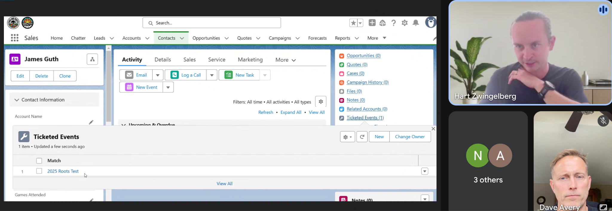

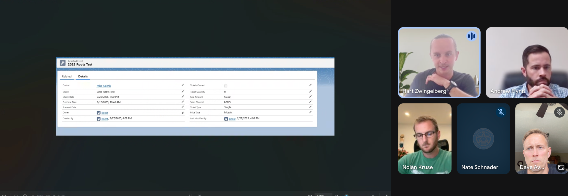

The above is very powerful. We know when they bought. What gate they are entering through and more.

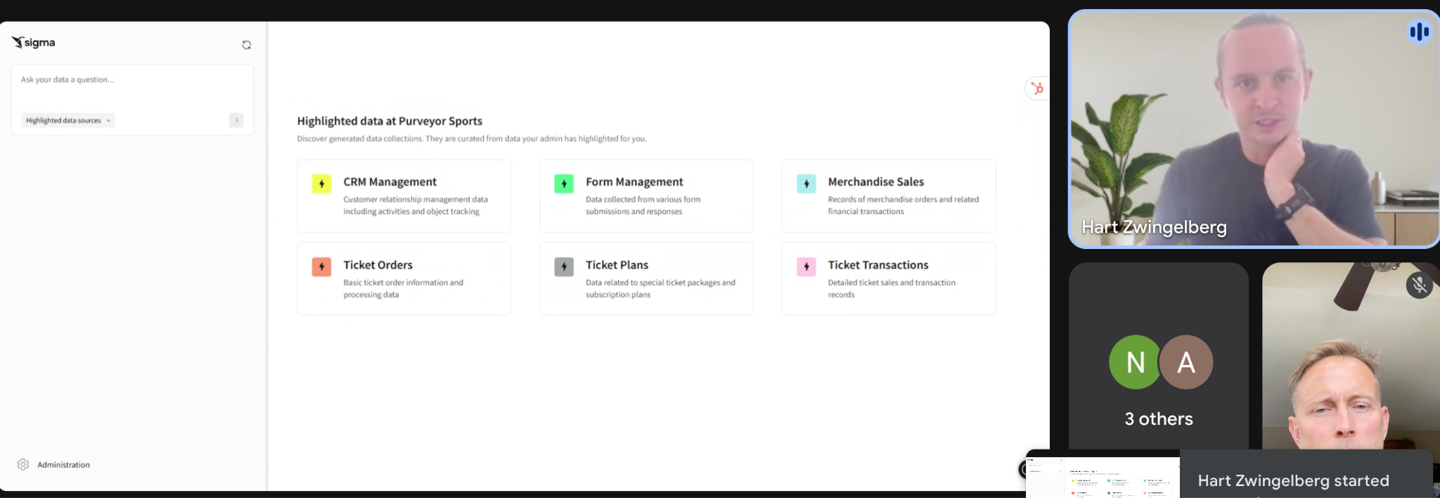

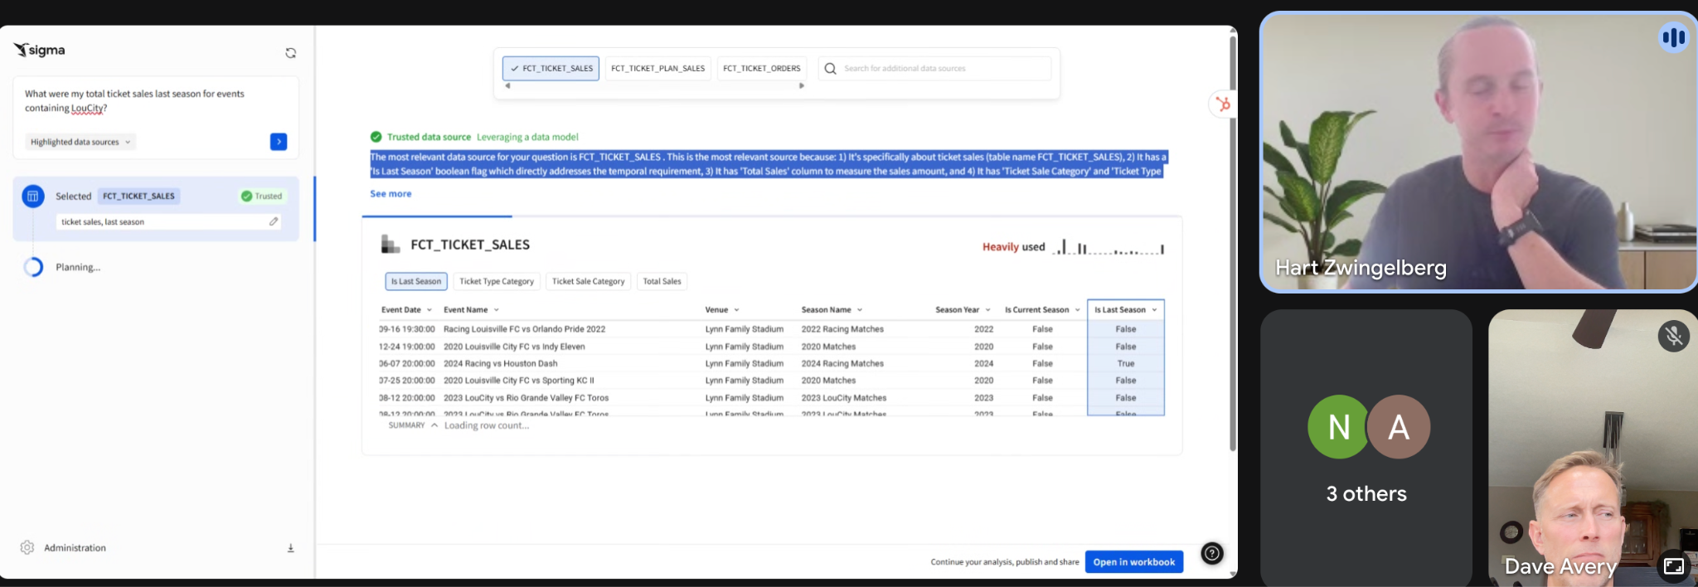

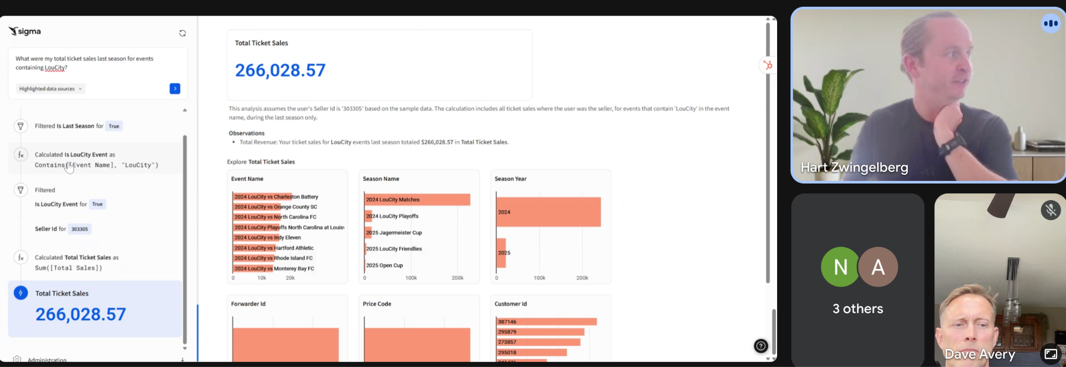

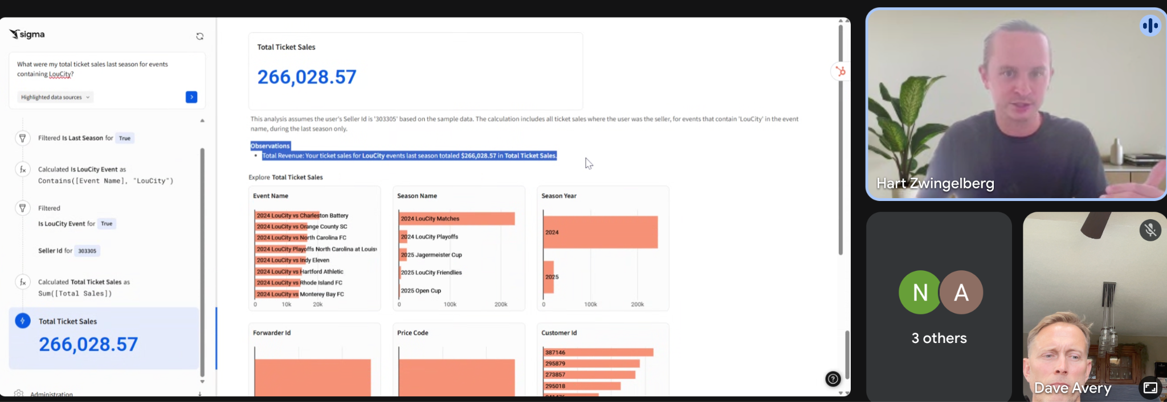

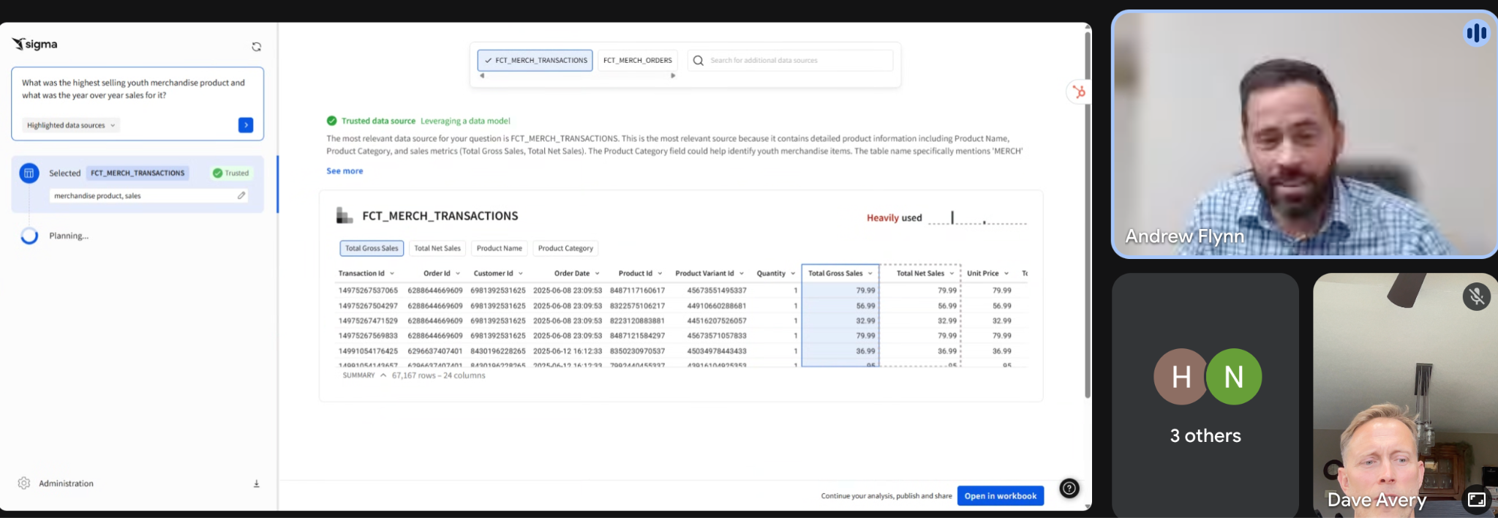

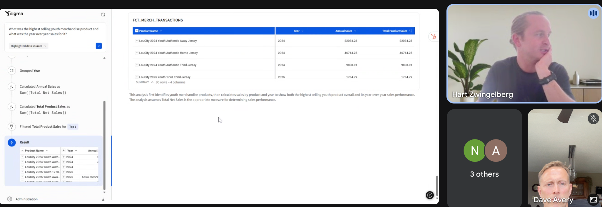

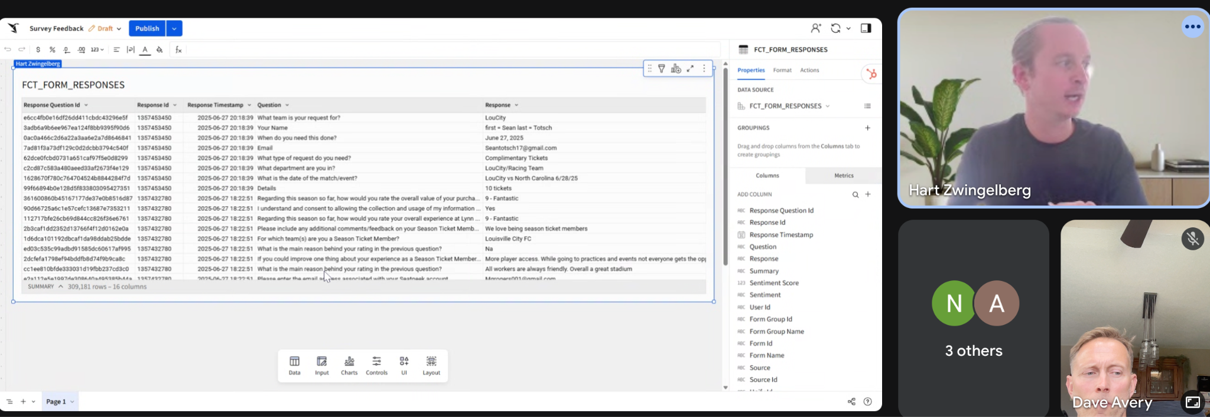

* They use Core Text in Snowflake to support this.
* I expressed that this will apply to all SF customers not just sports orgs. They have something special here.
* Nate said hit him up on the side to discuss opportunities.
* I gave my green light to get this going.
* Andrew brought up the need for sponsorship with purveyor sports. Hart responded with we use custom SF objects with destination in Snowflake.
* Andrew also asked about how clubs are using Purveyor Sports from a marketing standpoint.
* **~~ACTION ITEM~~**: Hart, to send me their Ticketing data dictionary. We can use this to build our custom object.
  + Hart sent this right after the call. I put the doc in drive - <https://docs.google.com/spreadsheets/d/1RdhqCrIEGBRxV6K83SwuerYawX96ONQe/edit?usp=sharing&ouid=109911022161712648722&rtpof=true&sd=true>
  + He also sent the following screenshots.

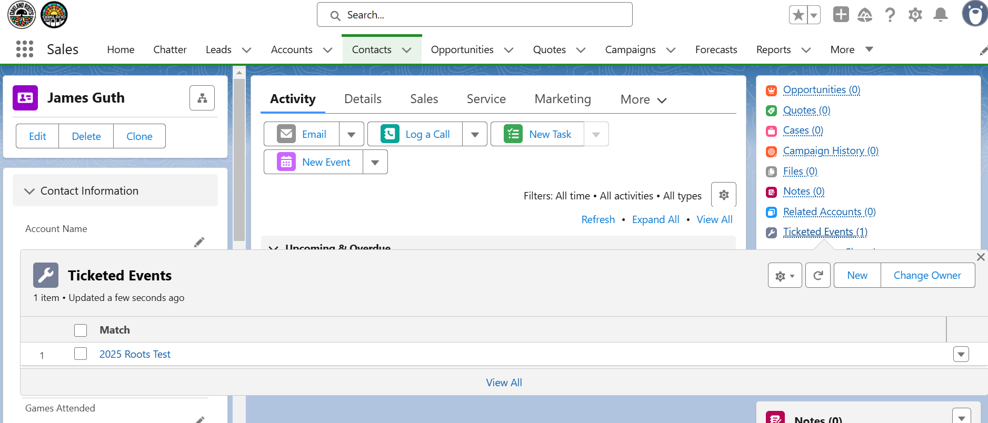

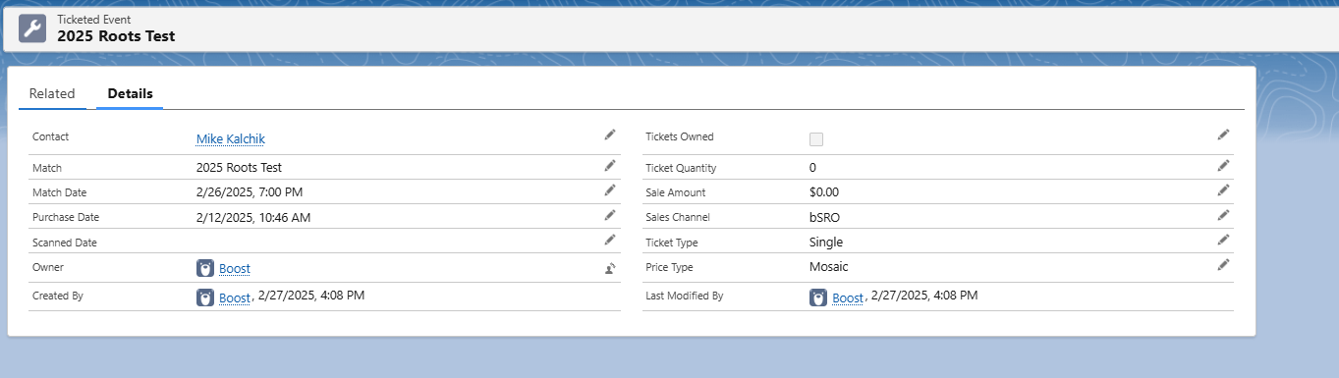

# 9/5/2025 - Production Support Call - Day 2 of 5

Attendees: Dave, Hitesh

* Discussed testing assessment. . . looking good.
* Discussed reporting/dashboards. Hitesh to work on reports & dashboards in QA and we will present them to you asap.

# 9/8/2025 - Production Support Call - Day 3 of 5

Attendees: Dave, Hitesh, Noah, Steve, Rahsaan, Makenna

* Rahsaan asked about where to see Unify data. We are currently working on this project. . . stay tuned
* Got Makenna into production.
* **~~ACTION ITEM~~**: Hitesh, When creating a new Task from a Lead, Account, Contact, or Opportunity, have it include the same elements as it does when creating a New Task from the To Do List.

Our ongoing Project Notes can be seen here,<https://docs.google.com/document/d/1AbO_Yv5e-kvXJSLFrxppk7BU_KzwcB_TCNVr9_Nra6E/edit?usp=sharing>

# 9/5/2025 - Purveyor Sports with LouCity

Attendees: Rusty Fazio (VP of Technology at LouCity), Andrew, Steve, Noah, Hart, Jocelyn Prieto (LouCity - Sr. Director Sales Ticketing)

* LouCity did a POC with Purveyor Sports, brought them on fully this year.
* They left Salesforce last year moving over to HubSpot, they also use Mail Chimp, SeatGeek and Shopify.
* Rusty is very happy with what they are getting from Purveyor Sports.

# 9/9/2025 - Production Support Call - Day 4 of 5

Attendees: Dave, Bryce, Noah, Makenna, Steve, Rahsaan, Hitesh

* Quick chat about Purveyor Sports. Noah mentioned Purveyor Sports was Boost.
* **~~ACTION ITEM~~**: Hitesh, When creating a new Task from a Lead, Account, Contact, or Opportunity, have it include the same elements as it does when creating a New Task from the To Do List.
  + 9/9 - Yes, complete
* Noah brought up that he want to start a new campaign “2025 STH with New Stadium Deposits”.
  + **~~ACTION ITEM~~**: Dave, create new field, Active Campaign Name (text(255)).
  + **~~ACTION ITEM~~**: Dave lead a working session with Noah & Steve on how to data load updates.

Our ongoing Project Notes can be seen here,<https://docs.google.com/document/d/1AbO_Yv5e-kvXJSLFrxppk7BU_KzwcB_TCNVr9_Nra6E/edit?usp=sharing>

# 9/10/2025 - Production Support Call - Day 5 of 5

Attendees: Dave, Bryce, Noah, Steve, Rahsaan, Hitesh

* Noah brought up that he want to start a new campaign “2025 STH with New Stadium Deposits”.
  + **~~ACTION ITEM~~**: Dave, create new field, Active Campaign Name (text(255)).
  + **~~ACTION ITEM~~**: Dave lead a working session with Noah & Steve on how to data load updates.
  + Bryce asked about how to mark a lead as closed lost. The person he was talking to decided she didn’t want season tickets.
  + Noah is progressing nicely through trailhead modules.a
  + Bryce told us how Steve sent him a lead Shannon Cross, when Bryce searched for her he found her as a Person Account. He logged a call and asked how to mark this as closed lost. We didn’t plan for this and in this scenario Bryce should create a new Opportunity off the Person Account, then marking them as closed lost.
    - **~~ACTION ITEM~~**: Dave, clean up the new Opportunity screen from the account. We didn’t account for this flow originally.
      * Account related list - <https://help.salesforce.com/s/articleView?id=002519999&type=1>
      * Opportunity tab - <https://help.salesforce.com/s/articleView?id=002519999&type=1>
  + **~~ACTION ITEM~~**: Dave, extend meetings one more day to review this process.
* Noah is working on Trailmix for the team to learn more about the system.
* We want to keep these support calls to help with adoption.
  + **~~ACTION ITEM~~**: Dave, create Tuesday & Thursday calls for four more weeks.

Our ongoing Project Notes can be seen here,<https://docs.google.com/document/d/1AbO_Yv5e-kvXJSLFrxppk7BU_KzwcB_TCNVr9_Nra6E/edit?usp=sharing>

# 9/15/2025 - Purveyor Sport Next Steps Call

Attendees: Dave, Andrew, Todd

* Andrew mentioned he has a one-on-one with the CRO of LouCity.
* Purveyor Sports pricing model.

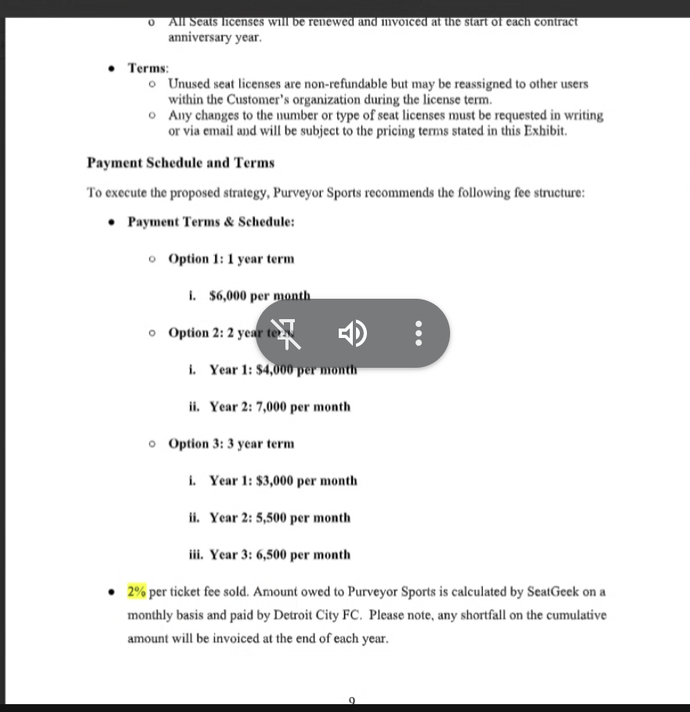

* If we use the 2% option and go over, Purveyor Sports credits us for the following year.
* SeatGeek already charges 5-6%. The 2% would be on top of this.
* Andrew said Purveyor Sports (PS) will work with us as a BI advisor/director.
* This will also integrate with merchandise, mail chimp.
* **ACTION ITEM**: Andrew, ask PS if they can add an “Opt-Out” clause. If we do option 3 (3-year term) and want to get out after year 2. How does that work?
* **ACTION ITEM**: Todd/Andrew, talk to Sean about which option we want to go with.
* **~~ACTION ITEM~~**: Dave, kick off the technical request with PS.
* I asked if we have data analytics on our websites (old and new stadium). Andrew said yes, we have to talk about how to get this into the data warehouse.

# 9/15/2025 - Support Call

Attendees: Dave, Noah, Steve, Hitesh, Rashaan, Makenna, Bryce

* Dave, walked through a new Opportunity creation flow. Looks good to the team.
* Discussed next steps with Purveyor Sports. Noah already took care of requesting the Ringside. Didn’t cc Dave but will in the future. As of now, 1:45 PM ET, they haven’t responded. Nate & Hart were CC’d on this request.
* Discussed future meetings and Dave requested just meeting on Thursdays. The team agreed. **~~ACTION ITEM~~**: Dave set up these at 2:00 for four weeks.

Our ongoing Project Notes can be seen here,<https://docs.google.com/document/d/1AbO_Yv5e-kvXJSLFrxppk7BU_KzwcB_TCNVr9_Nra6E/edit?usp=sharing>

# 9/18/2025 - Production Support Call

Attendees: Dave, Hitesh, Makenna, Rahsaan, Steve, Noah, Bryce

* Rahsaan gave an update they are busy over there. Last four home games in flight. Positioning to make the playoffs, might even host a playoff game.
* Rahsaan talked about moving stuff off of HubSpot onto Salesforce. They are still in HubSpot for renewals.
* Noah talked about getting notes/activities off of hubspot into Salesforce. I responded with our options.
  + Old school data export/import - requires dev time
  + Manually copy/paste as needed
  + Crazy Idea: leverage Purveyor Sports to do this with the AI and data warehouse.
* Steve mentioned this is an issue now as we are focussing on renewals.
* No new info is going into HubSpot. They would still buy from SeatGeek. It will help when that integration is in place.
* In HubSpot we have 52k~ contacts.
* Our primary concern is getting the notes from HubSpot for contacts we’ve done business with. If a person is in HubSpot & SF already, we update them with our notes. If they aren’t in SF at all, we ignore them.
* **~~ACTION ITEM~~**: Dave & Noah to have a working session on how to export notes from HubSpot. Done - 10 AM tomorrow, 9/19.
* Noah asked the reps if there are any other blockers besides this HubSpot issue. Rahsaan rattled off:
  + Google Sheets
  + Email (could look at an Outlook/Google integration)
  + Unify
  + Base Camp (internal only)
  + Slack (internal only)
  + Call Harbor
* Bryce said the HubSpot thing is the biggest issue. He also mentioned the SeatGeek integration is a big win. Knowing what people bought is huge.
* Noah is working on campaigns for sales but wants to get things going in Salesforce.
* Noah mentioned Justin at SeatGeek is running the API request up the flag pole. Waiting on this to continue.

Our ongoing Project Notes can be seen here,<https://docs.google.com/document/d/1AbO_Yv5e-kvXJSLFrxppk7BU_KzwcB_TCNVr9_Nra6E/edit?usp=sharing>

# 9/18/2025 - Working Notes

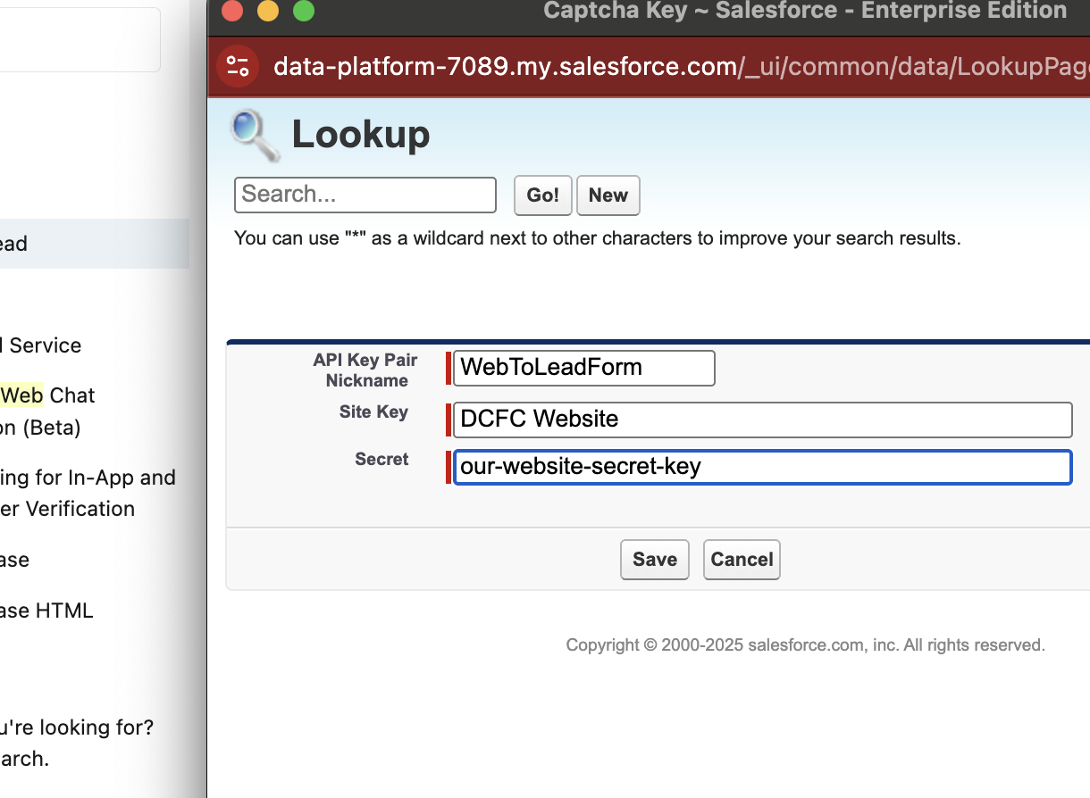

# 9/19/2025 - Dave/Noah Sync

* Lead owner is Noah on Web-to-Lead form.
  + **ACTION ITEM**: Dave look into getting this round robin.
* **ACTION ITEM**: Dave, turn on Notify Lead Owner after this works.
* Noah mentioned he built a trailmix for the team.

# 9/25/2025 - Production Support Call

Attendees: Dave A., Hitesh, Noah, Bryce, Makenna

* Noah - put together the Gmail integration. Shared this with Rahsaan, Bryce and himself. Noah needs to connect with Makenna. Connected email for the last 180 days. This will help with adoption.
* HubSpot Notes
* Reports & Dashboards
* Web-to-Lead, we are still pointing <https://www.detcityfc.com/detroit-city-fc-season-tickets/> to the google form. We will update this as soon as we figure out the Round Robin issue.
  + **ACTION ITEM**: Dave/Hitesh get this working properly.
* Noah talked about data loading records into SF for chunks of work the team needs to do. This can easily be done. Noah to connect with Dave when he is ready for this.